COVID-19 and its Impact on the Global Economy

Group Members
Nabira Khan 23K-0914
Muhammad Saim 23K-0708
Ali Sharjeel 23K-0904
Abdullah Arshad 23K-0794
Saniya Bhojwani 23K-0658

Date of Submission
November 18, 2024

Submitted to
Sir Micheal Hieman Simon
Lecturer, Principles of Economics

Access the Soft Copy of This Report: https://tinyurl.com/rj3pc2cv


ABSTRACT
The COVID-19 pandemic has profoundly impacted the global economy, triggering an unprecedented economic crisis that disrupted employment, supply chains, and industrial stability. This report explores the multifaceted effects of the COVID-19 pandemic on global economies, examining key factors such as GDP, government debt, unemployment, recession, and supply chain disruptions. The report delves into regional disparities, the sectors most affected by the crisis, and evaluates the effectiveness of government interventions. Furthermore, it offers strategies for economic recovery and stresses the importance of developing resilient economic systems that can adapt to future crises, ensuring long-term stability.

COVID 19 OVERVIEW

The COVID-19 pandemic, caused by the SARS-CoV-2 virus, was first detected in December 2019 in Wuhan, China. Initially identified as an outbreak of pneumonia, it quickly became a global health crisis. The World Health Organization (WHO) declared it a Public Health Emergency of International Concern in January 2020 and a pandemic in March 2020.

COVID-19 is primarily transmitted through respiratory droplets, making it highly contagious. Its rapid spread overwhelmed healthcare systems, causing high infection rates, significant morbidity, and a surge in fatalities. In response, governments implemented strict public health measures, including lockdowns, travel bans, social distancing, and mask mandates to reduce transmission and protect healthcare systems.

The pandemic’s impact extended beyond healthcare, deeply affecting the global economy. Lockdowns forced businesses to close, disrupted international trade, and caused a sharp decline in consumer demand. Key industries like tourism, retail, hospitality, and manufacturing faced major setbacks, while the aviation sector saw a dramatic fall in air travel. Global supply chains experienced bottlenecks, exacerbated by labor shortages. This led to widespread job losses, reduced industrial output, and an economic contraction not seen since the Great Depression.

Additionally, the pandemic triggered social and psychological consequences. The shift to remote work and learning, coupled with uncertainty, had a significant impact on mental health, increasing anxiety, depression, and stress-related disorders. The closure of schools and universities and the transition to online education further highlighted inequalities in access to education.

In conclusion, COVID-19 has profoundly impacted global health, economies, and societies. The pandemic exposed vulnerabilities in public health systems, economic structures, and social safety nets, prompting a reassessment of strategies for building resilience against future crises. This research will explore the specific economic effects of the pandemic, focusing on GDP, employment, supply chains, and consumer behavior.

UNEMPLOYMENT RATES
The COVID-19 pandemic led to a sharp rise in global unemployment rates, affecting millions of workers across various sectors and regions. Lockdowns, restrictions on movement, and social distancing measures forced many businesses—particularly in hospitality, retail, and tourism—to downsize or close entirely, resulting in unprecedented job losses. The pandemic exacerbated existing vulnerabilities, with lower-income workers, young people, and women experiencing particularly high rates of unemployment. This global surge in unemployment not only impacted individuals’ livelihoods but also placed immense pressure on economies, highlighting the need for targeted strategies to support recovery and reduce unemployment in the post-pandemic world.
Factors Affecting Employment Rates
The impact of COVID-19 on global unemployment rates has drawn striking comparisons to the Great Depression of the 1930s, as both crises led to unprecedented job losses and economic contraction worldwide. Like the Great Depression, the pandemic created a ripple effect that intensified vulnerabilities in employment and economic stability, fueled by multiple interconnected factors:
- Lockdowns and Social Distancing: Lockdowns and social distancing forced widespread business closures, particularly in sectors requiring physical presence, leading to significant layoffs and a rapid increase in unemployment.
- Supply Chain Disruptions: COVID-19 severely disrupted supply chains, impacting production and distribution. Job losses followed as shortages and delays destabilized sectors like manufacturing and retail.
- Health Concerns in the Workplace: Health risks prevented many workers in essential and public-facing roles from continuing, creating labor shortages and contributing to employment instability.
- Limitations of Remote Work: Many sectors, such as manufacturing and retail, could not transition to remote work, leading to mass layoffs in roles that required on-site presence.
- Drop in Consumer Demand: Economic uncertainty and health concerns led to a steep decline in consumer spending, forcing businesses to downsize or close and driving unemployment rates higher.
- International Trade and Export Barriers: Trade restrictions disrupted industries reliant on exports, like automotive and electronics, causing job losses as global demand and supply fell.

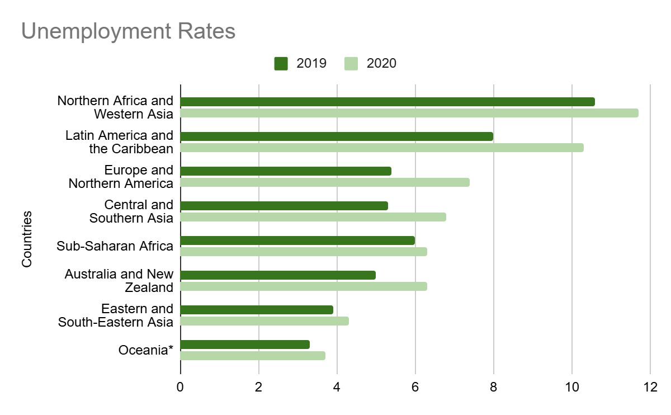
Comparison and Data Analysis
Analysis: Northern Africa and Western Asia saw the largest increase, from 10.6% to 11.7%, while Latin America and the Caribbean also experienced a significant jump, from 8% to 10.3%. Europe and Northern America saw a more modest increase, from 5.4% to 7.4%, reflecting the widespread job losses and disruptions caused by the pandemic. Central and Southern Asia, Sub-Saharan Africa, and Australia and New Zealand also experienced increased unemployment rates, with the global average rising from 5.4% in 2019 to 6.5% in 2020. The pandemic led to widespread shutdowns, layoffs, and economic challenges that drove these increases in unemployment.

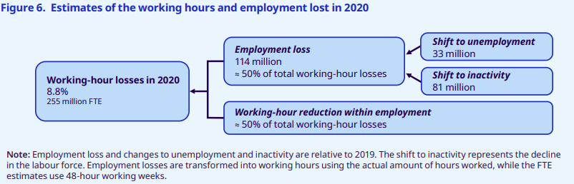
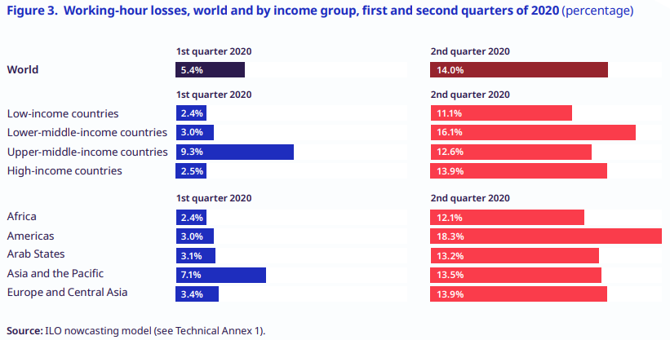
Figures 6 and 3 analyze the global working hours loss in 2020, showing a staggering decline of 8.8% in total hours worked worldwide. This was equivalent to the loss of 255 million full-time jobs. The losses were most significant in the 2nd quarter in regions like Latin America and the Caribbean, where working hours fell by 18.3%, followed by Southern Europe with a 13.9% drop.
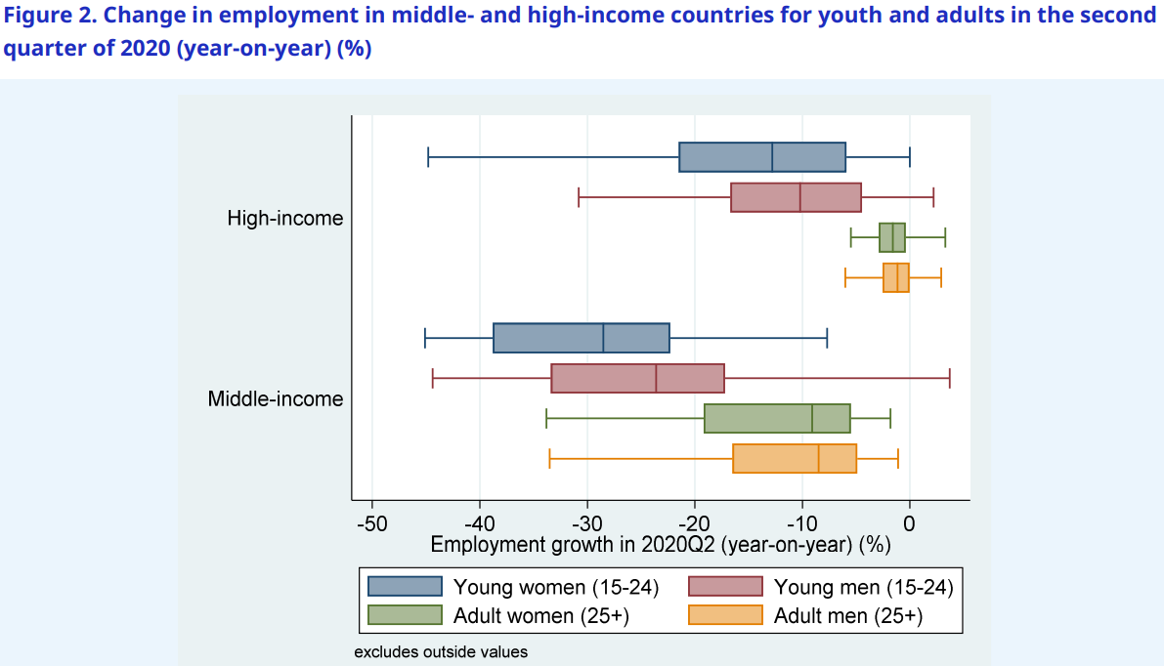

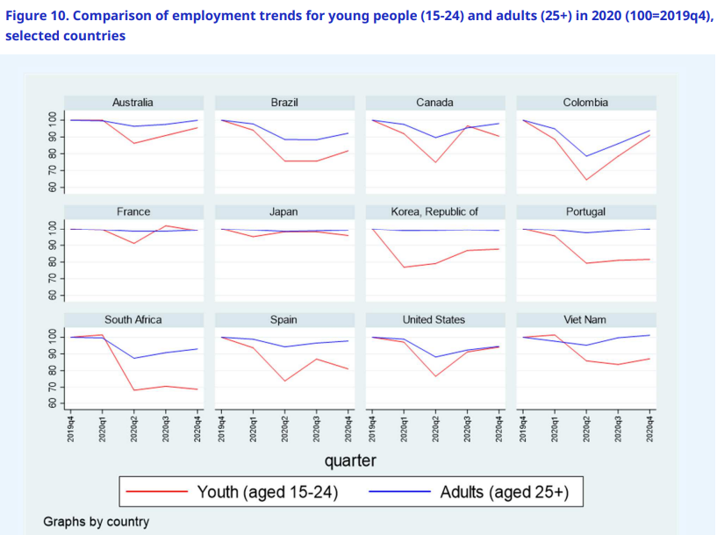
Young people, especially women, experienced substantial employment losses during the COVID-19 crisis, with young women in Latin America seeing declines of 25–45% in Q2 of 2020. Globally, youth employment dropped by 8.7% between 2019 and 2020, more than double the decline seen in adults (3.7%)% GDP decline correlated with an 8.1% employment drop for youth, compared to 6.3% for adults. In high-income countries, youth employment, particularly among young women, fell more sharply than adult employment, and the gap was even wider in middle-income nations, where young women’s employment declined by nearly 30%.
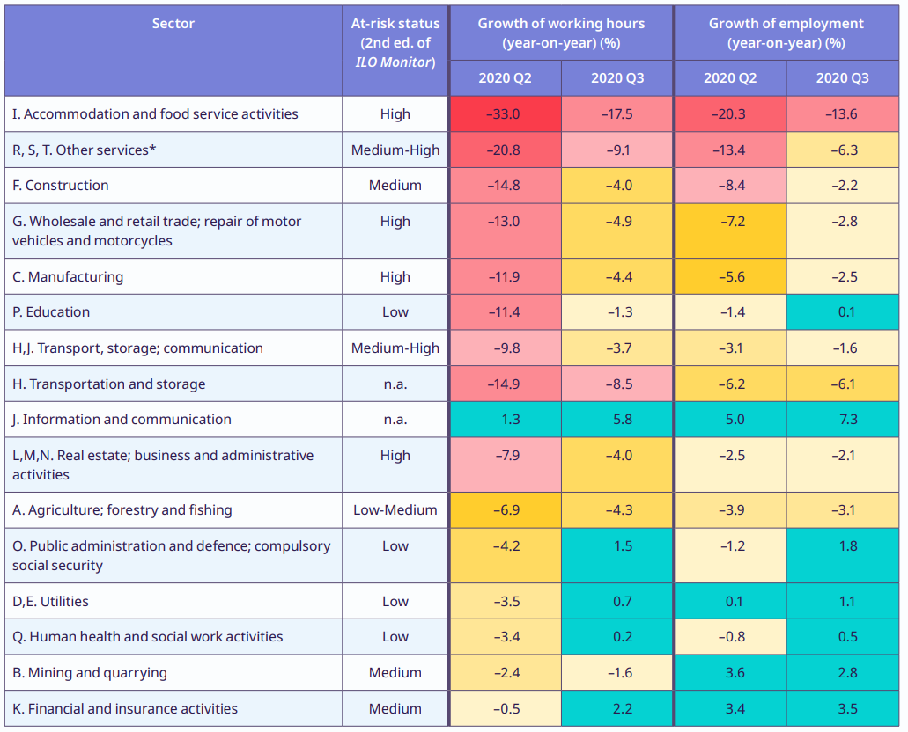
The table compares the sectoral working hours and employment growth rates in the second and third quarters of 2020, showing notable declines across most sectors, particularly those reliant on physical interaction or travel. The Accommodation and food services sector saw the sharpest drop in working hours at -20.8%, followed by transportation and storage at -17.9%. In contrast, sectors like information and communication experienced a growth of 1.5%, benefiting from the increased demand for remote services. Employment in manufacturing also declined by -10.7%, while healthcare experienced a positive growth of 5.1% due to higher demand during the pandemic. This reflects the uneven economic impact of COVID-19 across different industries.

Government Response and Recovery
During the COVID-19 pandemic, governments worldwide implemented various measures to combat rising unemployment and ensure economic stability. Key programs included:
- Wage Subsidies and Short-Time Work Schemes: Germany’s Kurzarbeit (short-time work scheme) provided financial support to businesses, enabling them to retain employees despite reduced demand for goods and services. Similarly, France and Italy introduced short-time work programs that subsidized wages for employees with reduced hours to prevent layoffs, especially in hard-hit sectors such as hospitality and retail (International Monetary Fund [IMF]).
- Enhanced Unemployment Benefits: In the United States, the Pandemic Unemployment Assistance (PUA) program extended benefits to gig workers, freelancers, and other self-employed individuals who were previously ineligible for unemployment support. In Canada, the Canada Emergency Response Benefit (CERB) provided direct financial assistance to individuals who lost income due to the pandemic. Australia's JobSeeker program increased payments for unemployed individuals (Institute for Government).
- Direct Financial Aid: Japan provided cash subsidies to workers directly affected by the pandemic, helping them cover living expenses. The U.S. distributed stimulus checks to citizens to support economic activity and reduce financial strain during lockdowns (IMF).
- Supporting Business Continuity: The United Kingdom introduced the Coronavirus Job Retention Scheme (furlough scheme), which allowed employers to claim financial support to cover a portion of employee wages, thus preventing mass layoffs. Similarly, Australia’s JobKeeper payments supported businesses in retaining employees despite a significant decline in operations. South Korea focused on job retention and creation programs targeting youth employment in digital sectors (IMF).
- Global Initiatives: The European Union implemented the SURE (Support to mitigate Unemployment Risks in an Emergency) program, which helped member states subsidize wages and support part-time work arrangements in industries severely affected by the pandemic (IMF).

These policies were crucial in mitigating unemployment spikes, stabilizing income, and keeping businesses afloat during the global crisis, although their success varied depending on the local context (IMF, Institute for Government).

Future Recovery and Outlook
The global labor market is navigating a slow and uneven recovery from the COVID-19 pandemic, with several key factors influencing the future trajectory of unemployment and workforce dynamics.

- Rising Unemployment
Global unemployment is projected to rise to 5.2% in 2024, a reflection of ongoing challenges in labor markets, particularly in low-income countries, where unemployment could see a significant spike. Economic disruptions caused by the pandemic have delayed the return of many workers to the labor force, especially in regions heavily dependent on sectors such as tourism, hospitality, and retail​

- Widening Income Disparities
Income inequality remains a major issue, with low-income countries facing higher unemployment rates, potentially up to 20.5% in certain regions. The widening unemployment gap is exacerbated by inflation, which is eroding the purchasing power of households, particularly in developing nations and the G20 economies. As the cost of living rises, disparities in income are becoming more pronounced, making it harder for low-income workers to secure jobs that provide financial stability​

- Productivity Slowdown
Despite advances in technology, productivity growth is expected to remain slow. While automation and digitization are increasing in various industries, these technological shifts are not translating into widespread productivity improvements or job creation. Many workers, particularly in low-skill sectors, face difficulties adapting to the evolving job market, further delaying global economic recovery​

- Inflation Impact on Living Standards
Inflation is another critical challenge impacting global recovery. In many G20 countries, rising prices have begun to erode living standards, particularly for lower-income households. As wages stagnate and inflation continues to rise, households find it increasingly difficult to meet basic needs. The financial strain from inflation, combined with ongoing unemployment and reduced social benefits, further hinders economic stability​

- Youth Unemployment and Gender Gaps
Youth unemployment remains a persistent issue globally, with many young workers struggling to enter the labor force. In contrast, women are expected to recover more quickly than men in terms of workforce participation, but their recovery is still slower compared to pre-pandemic levels. Young workers, especially those in vulnerable sectors, face long-term challenges in securing stable, well-paying jobs​

- Uncertain Recovery
Structural challenges, such as the persistence of informal employment, economic inequality, and regional disparities, are hindering the global recovery process. These issues are particularly evident in countries with large informal sectors, where workers are often excluded from government support programs and lack job security. The ongoing impact of these structural weaknesses is likely to prolong the recovery period, especially in developing economies​

Key Policy Recommendations for Recovery
Wage Subsidies and Job Creation Programs: Targeted policies that promote wage subsidies and create new job opportunities will be crucial in alleviating unemployment and boosting economic recovery. Governments should focus on sectors with high potential for growth, such as digital technology, green energy, and healthcare​
Strengthening Social Protection: Enhanced unemployment benefits and social safety nets are essential to support workers who remain unemployed due to the pandemic's effects. Expanding access to unemployment benefits and social protection programs will reduce the risk of long-term unemployment​
Investment in Skills and Reskilling: Governments should prioritize investing in education and skill development, particularly for youth, to equip them with the digital, technological, and sustainable industry skills necessary for the evolving job market. Training programs that target both future-focused industries and family business development will help create a competitive and adaptable workforce in the post-pandemic economy.
Reducing Inequality: Measures to reduce income inequality, including progressive taxation and improved wage policies, will be crucial for promoting inclusive growth and addressing the disparity between high-income and low-income countries​
Overall, while some progress has been made in addressing the economic and employment challenges caused by COVID-19, the road to recovery remains uncertain. Targeted, inclusive policies are needed to ensure that the benefits of recovery are shared widely across countries and demographics.

Conclusion
In conclusion, the COVID-19 pandemic dramatically reshaped the global employment landscape, causing unprecedented job losses and widening socioeconomic inequalities. As we examine these shifts, we observe that recovery is complex, with certain groups—particularly low-income and informal workers, young people, and women—facing continued hardship. This analysis underscores the need for proactive and inclusive policy responses to mitigate these impacts.
Our perspective highlights the importance of a multifaceted approach to recovery, focusing on job creation in growth sectors, robust social protection systems, and accessible reskilling opportunities. As we move forward, it's essential to address income disparities and strengthen workforce resilience through targeted policies. By investing in these areas, we can foster a more equitable and sustainable recovery, ensuring that the gains are broadly shared across regions and demographics.

REFERENCES

International Labour Organization (ILO). (2021). ILO Monitor: COVID-19 and the World of Work. Seventh Edition. Updated estimates and analysis on the pandemic’s global impact on employment and income trends. Retrieved from ILO website.

International Labour Organization (ILO) & Organisation for Economic Co-operation and Development (OECD). (2021). The Impact of the COVID-19 Pandemic on Jobs and Incomes in G20 Economies. A report prepared at the request of G20 Leaders during Saudi Arabia’s G20 Presidency. Retrieved from ILO website.

International Labour Organization (ILO). (2021). An Update on the Youth Labour Market Impact of the COVID-19 Crisis. This report highlights the disproportionate impact of COVID-19 on youth employment globally. Retrieved from ILO website.

OECD (2021). Employment Outlook 2021: Navigating the COVID-19 Crisis. OECD Publishing. Available at www.oecd.org.

International Monetary Fund (IMF). (2021). COVID-19 and Employment: The Role of Unemployment Support Programs. IMF. Available at www.imf.org.

Institute for Government. (2021). COVID-19 and the Labor Market: An Analysis of Wage Subsidies, Unemployment Benefits, and Stimulus Programs. Institute for Government. Retrieved from www.instituteforgovernment.org.uk.

SUPPLY CHAIN DISRUPTIONS
The COVID-19 pandemic triggered an unprecedented level of disruption in global supply chains, profoundly affecting the production, transportation, and delivery of goods worldwide. From raw materials to finished products, the pandemic impacted nearly every stage of the supply chain, resulting in delays, shortages, and significant price fluctuations. As lockdowns and restrictions limited manufacturing capacity and delayed shipments, sectors including healthcare, electronics, automotive, and consumer goods struggled to maintain supply levels, revealing vulnerabilities and dependencies within global trade networks.
Factors Contributing to Supply Chain Disruptions
The COVID-19 pandemic created several significant disruptions to global supply chains, primarily due to a combination of factors that collectively strained production and distribution systems:
- Labor Shortages: Workforce limitations due to illness, quarantines, and safety restrictions heavily impacted various sectors, especially logistics and transportation, where labor availability directly affects goods movement. Labor constraints were notable in the U.S. and UK, driven by factors like early retirements and increased caregiving responsibilities during lockdowns​
- Supply Bottlenecks and Component Shortages: Critical shortages, such as semiconductor chips, severely affected industries like automotive and electronics. During the initial lockdowns, demand for chips surged for home electronics, while automotive manufacturers reduced orders, creating a supply-demand mismatch that intensified as car production resumed​
- Port Congestion and Shipping Delays: A massive demand shift from services to goods led to port congestion, container shortages, and shipping delays worldwide. This congestion was exacerbated by the closure of major ports during localized outbreaks, particularly in Asia, driving shipping costs up and creating bottlenecks in inventory flows​
- Fluctuating Demand and Inventory Management Issues: Companies faced a "bullwhip effect" where fluctuations in demand led businesses to stockpile materials, creating further demand surges and inflating supply pressures. This amplified disruptions, especially as firms scrambled to stabilize inventories amid uncertain forecasts​
- Dependency on Limited Suppliers: Many industries depended on a few suppliers for key components like semiconductors. This dependency was particularly felt in the automotive and electronics industries, where semiconductor shortages caused production halts worldwide​

Regional Analysis of Supply Chain Disruptions
Different regions and sectors felt the impact of supply chain disruptions uniquely, as visualized in multiple studies:
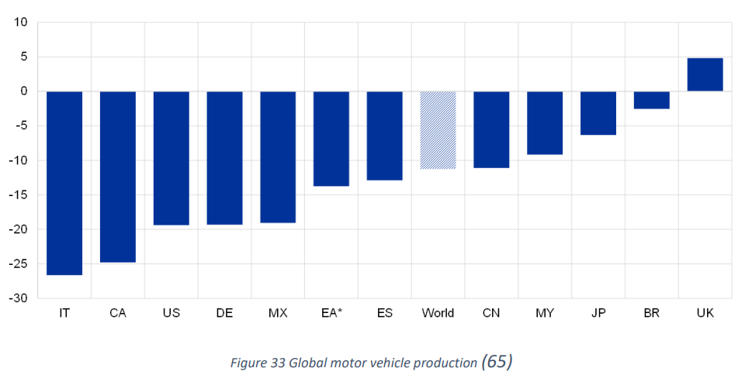
Manufacturing Sector in Asia: Asia, particularly China, is the primary supplier for many global manufacturers. Early lockdowns in Chinese factories delayed the supply of critical raw materials and components worldwide, triggering a domino effect in industries from electronics to healthcare. Countries like Vietnam and India gained prominence as alternatives to China for manufacturing. Figure 1 below illustrates the manufacturing delays in the automotive and electronics industries, showing a 30-40% decline in output in the first quarter of 2020​.

Port Congestion in the U.S. and Europe: As ports struggled to process increased volumes, waiting times surged. Figure 2 shows data on port efficiency in the Port of Los Angeles and Hamburg, where waiting times for container ships nearly doubled from 2019 levels by the end of 2021, reflecting severe congestion​

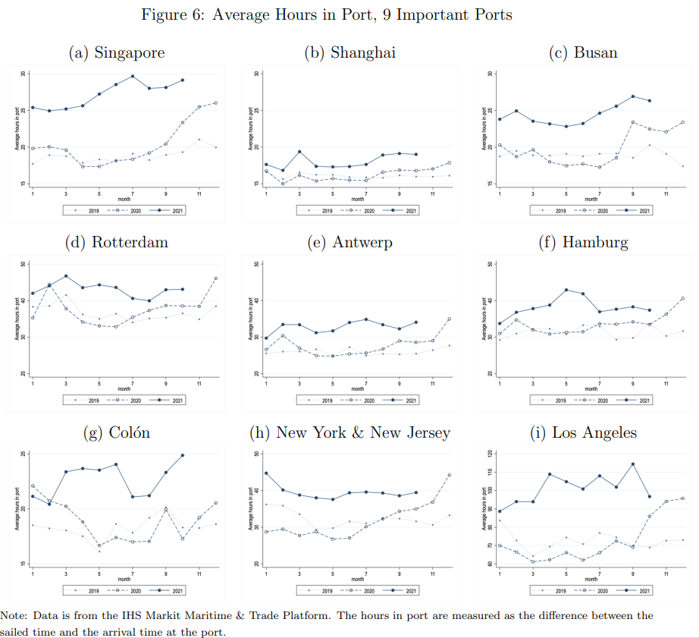
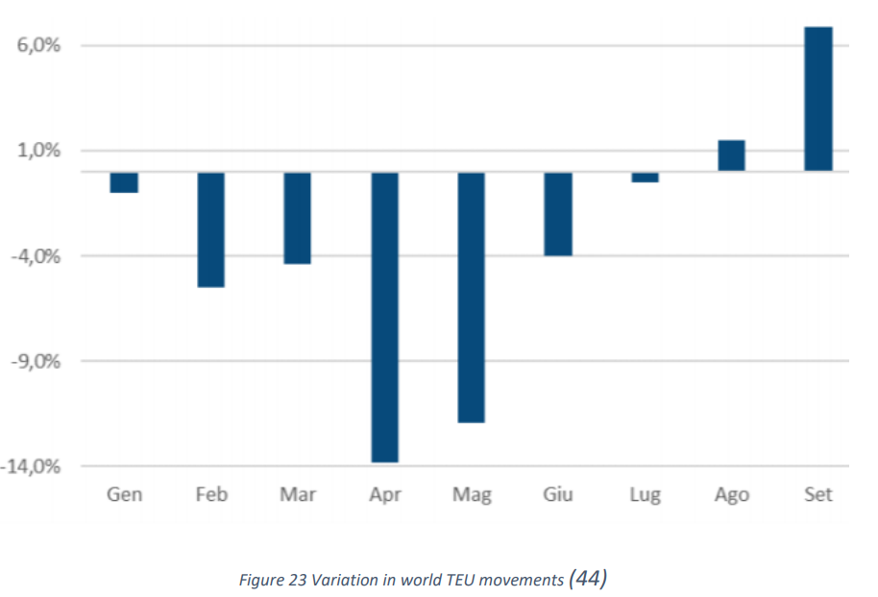
Consumer Goods and Retail in North America: The rise of e-commerce created additional strain on distribution networks, especially in North America. Retailers faced stockouts for high-demand goods due to shipping delays and last-mile delivery challenges.
Sectorial Analysis of Supply Chain Disruptions
Aviation and Aerospace: ICAO reported that in 2020, global passenger traffic fell by 60%, with a 50% reduction in airline seat capacity and a $372 billion revenue loss. By 2021, passenger traffic remained 49% below 2019 levels, with a 40% seat reduction and $324 billion in lost airline revenue. These declines reflect ongoing impacts of the pandemic on aviation.
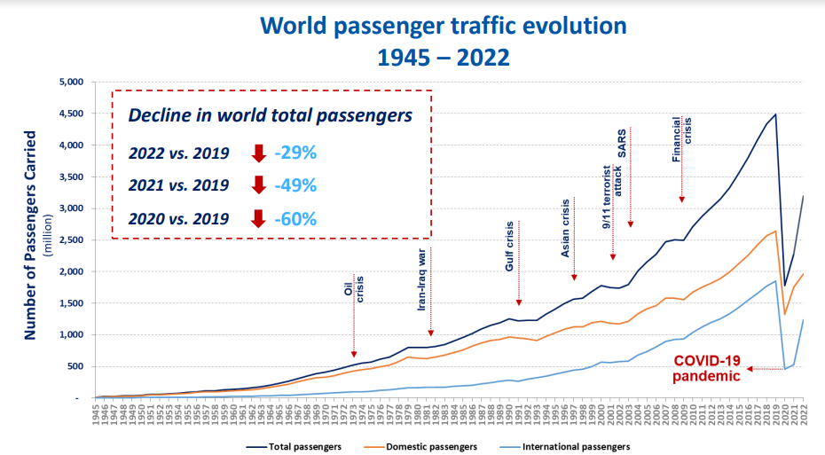
Passenger volumes dropped significantly during the pandemic, with global monthly revenue passenger kilometers (RPKs) at 33% of pre-pandemic levels in early 2021, recovering from a low of 6% in April 2020. Aircraft deliveries also fell by nearly 60%, marking one of the sharpest declines in decades

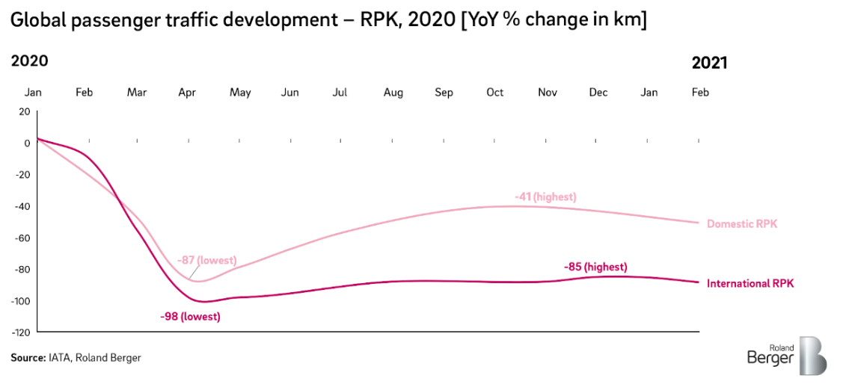
Construction: Lockdowns and supply chain disruptions led to delays in obtaining raw materials like steel and lumber, causing project slowdowns and increased costs in the construction sector.
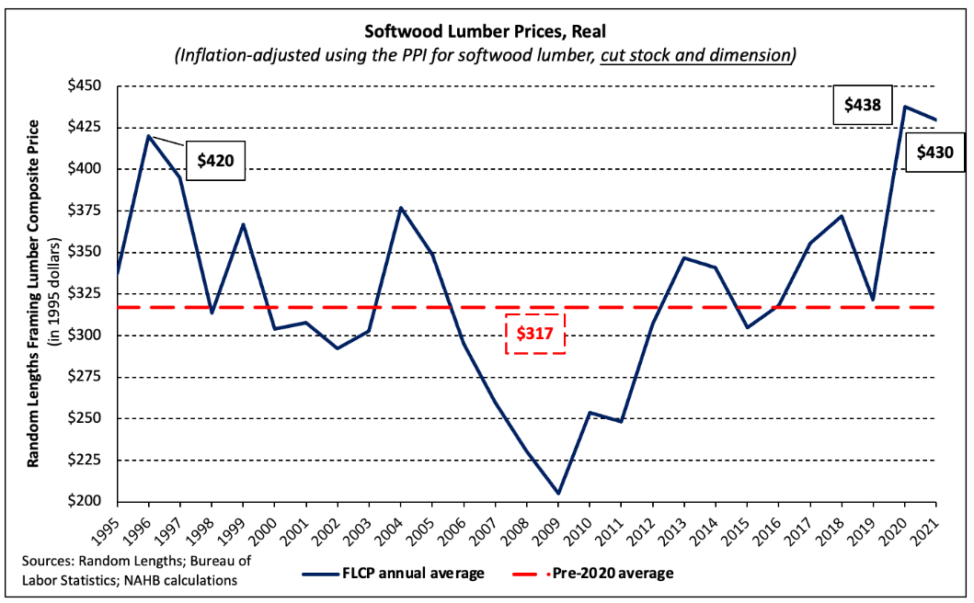
Lumber prices surged dramatically after the pandemic hit, with the industry benchmark FLCP increasing by 175% between April and September 2020, reaching all-time highs. By May 2021, prices nearly tripled, topping $1,500 per thousand board feet, setting a new record. Even after adjusting for inflation, the average price in 2021 was 17% above the 25-year average, breaking previous records.

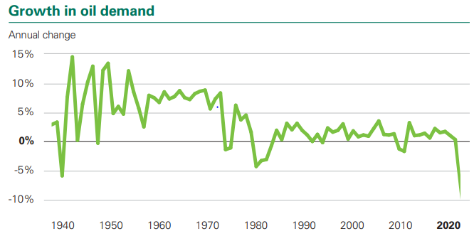
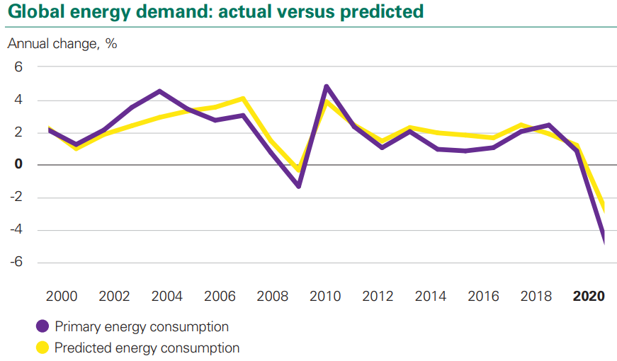
Energy: Demand for oil and gas plummeted due to reduced transportation and industrial activity. Renewable energy projects also faced delays due to supply chain disruptions for key components like wind turbines and solar panels. For the oil and gas industry, global demand dropped by almost 9% in 2020 compared to 2019, as transportation and industrial activity slowed dramatically.
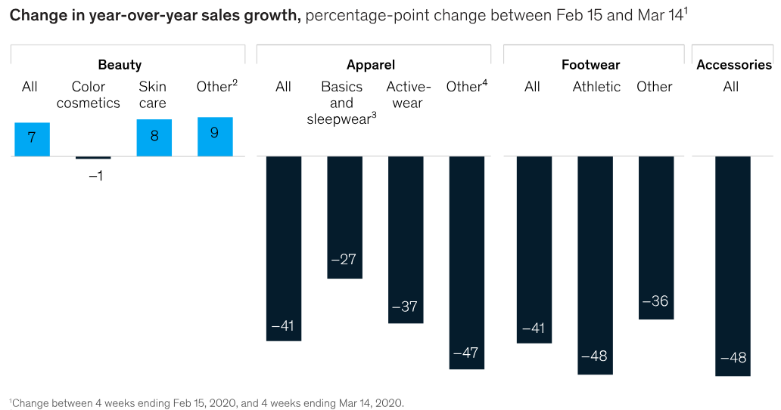
Fashion and Textiles: Factory closures in major production hubs like Southeast Asia led to delayed orders and stock shortages. Meanwhile, shifting consumer demand affected retail sales and created inventory mismatches

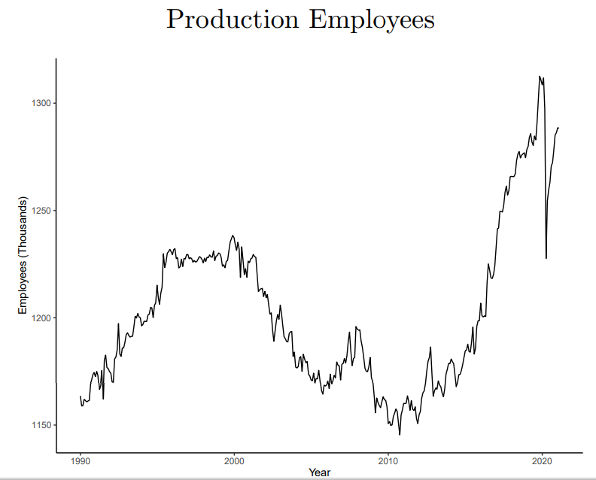
Food and Agriculture: Disruptions in logistics and labor shortages impacted the availability of fresh produce and other agricultural products. Food processing industries struggled with increased health regulations and workforce issues

Education and Technology: Disruptions in manufacturing delayed the supply of computers, tablets, and educational software, impeding the transition to remote learning for many regions. According to Canalys, global shipments of tablets and Chromebooks saw significant increases in 2020. Tablet shipments grew by 28%, while Chromebooks surged by 287% in the final quarter of the year
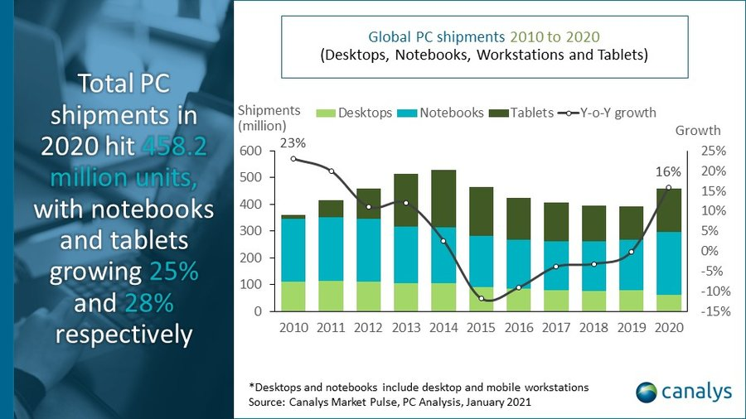
These impacts underscore the vulnerability of interconnected global supply chains and have driven organizations to focus on building more resilient, localized, and technology-driven systems.
Strategies for Mitigating Supply Chain Disruptions
To address these disruptions, companies and governments have taken steps to enhance resilience:
- Diversification of Suppliers: Companies are expanding their supplier bases to avoid over-reliance on single suppliers. This is particularly important for critical components like semiconductors, where a diversified supply chain can reduce vulnerability to localized disruptions​
- Enhanced Inventory Management: Many businesses are increasing their inventory reserves to ensure they can meet demand even during disruptions. This buffer strategy became widespread during the COVID-19 pandemic, with nearly 92% of companies increasing their stock levels​
- Digital Transformation and Real-Time Tracking: Digital tools such as blockchain, Internet of Things (IoT), and advanced track-and-trace technologies are being used to improve visibility, manage inventory, and track goods in real-time across the entire supply chain​
- Risk Management and Predictive Analytics: By incorporating predictive analytics, machine learning, and AI, businesses can anticipate potential disruptions (like pandemics or geopolitical events) and make data-driven decisions to mitigate risks​
- Flexible Manufacturing Models: Adopting agile manufacturing practices and flexible production capabilities allows companies to quickly shift production when needed, enhancing their ability to handle disruptions​
Conclusion
The COVID-19 pandemic highlighted the fragility of global supply chains, especially for industries dependent on just-in-time manufacturing and a limited supplier base. Through diversification, enhanced visibility, and increased digitalization, companies aim to build more resilient supply networks capable of withstanding future shocks. The path forward involves targeted policy interventions and industry collaboration to strengthen global trade networks and ensure continuity in the face of disruptions.
REFERENCES

World Trade Organization (WTO). (2020). COVID-19 and World Trade: A Story of Resilience. WTO. Retrieved from www.wto.org.
McKinsey & Company. (2020). COVID-19: The Impact on Global Supply Chains and How to Navigate the Crisis. McKinsey & Company. Retrieved from www.mckinsey.com.
Musella, L. (2021). The Impact of COVID-19 on the Supply Chain: Review of the Effects of a Pandemic Crisis on the Global Supply System and Analysis of its Fragilities. Degree Project in Mechanical Engineering, KTH Royal Institute of Technology. Retrieved from www.kth.se.
Canalys. (2020). Canalys Research: Impact of COVID-19 on Global Tech Markets. Canalys. Retrieved from www.canalys.com.
National Association of Home Builders (NAHB). (2020). The COVID-19 Impact on Homebuilding and Construction. NAHB. Retrieved from www.nahb.org.
International Civil Aviation Organization (ICAO). (2020). The Impact of COVID-19 on Global Aviation. ICAO. Retrieved from www.icao.int.

GROSS DOMESTIC PRODUCT (GDP)
Introduction
The COVID-19 pandemic triggered a severe global economic crisis, worsening inequality both within and between countries. Recovery is expected to be uneven, with emerging economies and disadvantaged groups facing prolonged setbacks. Unlike past crises, the pandemic prompted a swift and significant policy response, which helped mitigate immediate impacts. However, this emergency response also led to increased public and private debt.

The COVID-19 pandemic has had profound and far-reaching effects on the global economy, marking one of the most significant downturns since the Great Depression.

Global Economic Performance
In 2020, global GDP contracted by approximately 3.0%, a stark contrast to the 2.8% growth recorded in 2019. This downturn was primarily driven by stringent lockdown measures and a collapse in global trade, which severely disrupted economic activities worldwide 1

The United Nations projected that the global economy would lose nearly $8.5 trillion in output over two years due to the pandemic, effectively erasing four years of economic gains 2
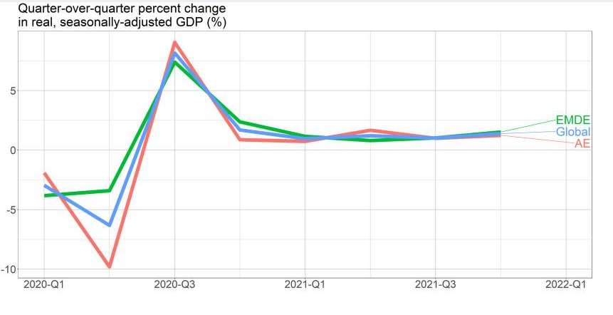
Fig 1

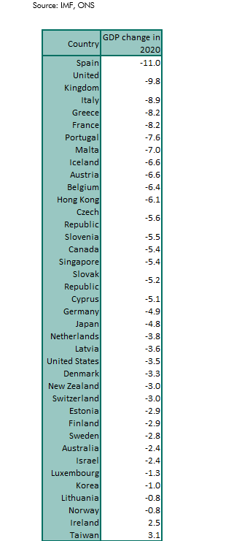

Fig 2

Sectoral Analysis

The impact of COVID-19 was not uniform across all sectors. Industries reliant on physical presence, such as travel and tourism, experienced dramatic declines. For instance, world trade was forecasted to contract by nearly 15% in 2020 due to reduced demand and supply chain disruptions 2. Conversely, sectors like e-commerce saw significant growth as consumers shifted to online shopping during lockdowns.

Comparative Economic Effects

The economic repercussions varied significantly between advanced economies and emerging markets. Advanced economies faced a sharper contraction, with GDP expected to decline by 5.0% in 2020, while developing countries were projected to shrink by only 0.7% 2.

However, emerging economies were more sensitive to lockdown measures, which had a pronounced negative effect on their economic activity compared to advanced economies 1.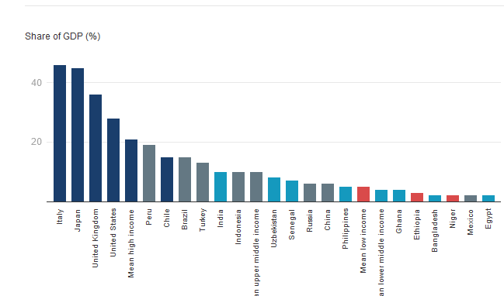
Fig 3

Insights and Implications

The data and trends illustrate that the pandemic has caused immediate economic turmoil while exposing vulnerabilities within global economic systems. The contraction of approximately 3.0% in global GDP in 2020 serves as a reminder of how quickly economic stability can be disrupted. This decline was not merely a statistic; it represented millions of jobs lost, businesses shuttered, and livelihoods upended. The disparities between advanced economies and emerging markets highlight a critical lesson: resilience and recovery are not uniform across the globe. The ongoing challenges faced by lower-income nations in bouncing back from this crisis underscore the need for a more equitable approach to global economic recovery. Moreover, as we look ahead, the long-term consequences of this pandemic on GDP will likely persist for years to come. The potential increase in extreme poverty and the widening inequality gap are issues that demand urgent attention from policymakers and international organizations.

REFERENCES

CEIC, Ritchie, H., Dong, E., Hale, T., International Monetary Fund and International Financial Statistics (2020-2022) Global Economic Indicators Database [Fig 1]
International Monetary Fund and Office for National Statistics (2021) COVID-19 Economic Impact Analysis [Fig 2]
National Center for Biotechnology Information (2023) 'Impact of COVID-19 on Global Economy'. Available at: https://pmc.ncbi.nlm.nih.gov/articles/PMC10030258/
United Nations (2020) 'COVID-19 to slash global economic output by $8.5 trillion over next two years'. Available at: https://www.un.org/en/desa/covid-19-slash-global-economic-output-85-trillion-over-next-two-years
World Development Report Team and International Monetary Fund (2022) Fiscal Monitor Database of Country Fiscal Measures in Response to the COVID-19 Pandemic [Fig 3]. Available at: https://www.imf.org/en/Topics/imf-and-covid19/Fiscal-Policies-Database-in-Response-to-COVID-19

GOVERNMENT DEBT RISK AND DYNAMICS
Impact of the COVID-19 Pandemic on Government Debt
The COVID-19 pandemic significantly impacted global government debt levels, amplifying fiscal risks for countries worldwide. Government debt soared as nations borrowed to finance emergency spending, providing economic relief and supporting healthcare infrastructure. These actions, while necessary to combat the pandemic, exposed governments to greater fiscal risks due to heightened debt burdens.

Borrowing to Finance Public Spending
Financing public spending through borrowing allows governments to distribute the cost of managing crises over time, spreading it across future taxpayers, See Section 4.7. However, as debt levels rise, the risk of governments being unable to meet their debt obligations increases, influenced by investor confidence in each government's fiscal stability.

Investor Confidence and Borrowing Costs
The willingness of investors to hold a country's debt is directly tied to their confidence in that government's ability to undertake fiscal measures to honor its debt obligations. Higher debt stocks relative to a country’s economy raise the fiscal costs of meeting obligations, creating an environment of increased investor caution, See Section 4.7. When investors perceive heightened risks, they may demand higher returns to compensate for the potential of future government defaults or debt erosion. This can increase the overall cost of borrowing, straining government budgets and limiting fiscal flexibility, See Section 4.9.

Constraints on Borrowing and Fiscal Actions
Countries with high levels of debt may experience increased borrowing costs and face limits on their capacity to take on additional debt. High debt constrains the ability of governments to undertake critical fiscal actions, as they may fear approaching an upper borrowing limit. As this limit is approached, the risk of default or measures to reduce real debt, such as inflation or financial repression, becomes more acute, See Section 4.8. While direct defaults on marketable debt have historically been avoided in advanced economies like the UK, there are instances where governments have restructured or adjusted debt to alleviate fiscal strain, See Section 4.8.

Sensitivity to Interest Rate Fluctuations
As debt levels increase, public finances become increasingly sensitive to interest rate fluctuations. Debt maturity structure is critical in determining how quickly rising interest rates lead to higher debt servicing costs; shorter maturities bring faster impacts on costs. In situations of significant debt, governments may resort to short-term borrowing, which further raises their exposure to interest rate increases, See Section 4.10. The interaction between debt levels and maturity structures can ultimately lead to a downward spiral, where rising interest rates result in unsustainable borrowing costs, forcing governments to restructure or default, See Section 4.10.

Long-Term Economic Consequences of High Debt
High debt levels also correlate with long-term economic consequences, particularly in the form of slower GDP growth. This inverse relationship, supported by empirical studies, suggests that increased government debt reduces private investment by driving up the cost of capital. Additionally, the anticipation of higher taxes to service debt may dampen economic growth, See Section 4.11. Lower growth rates can also result in higher debt accumulation, creating a cycle where debt burdens hinder growth, further exacerbating fiscal risks.

Case Study: The UK’s Debt Dynamics
In the UK, for example, government debt-to-GDP ratios have risen significantly over the past two decades, reaching a position among the highest of advanced economies by 2020. Despite the rise in debt, low yields on government debt have kept debt servicing costs relatively low, See Section 4.12. This decline in yields has been primarily driven by falling interest rates, which reduced the effective cost of borrowing even as debt levels reached post-war highs, See Section 4.12. These dynamics underscore how global debt is impacted not only by the absolute levels of borrowing but also by economic factors such as growth rates and interest costs.
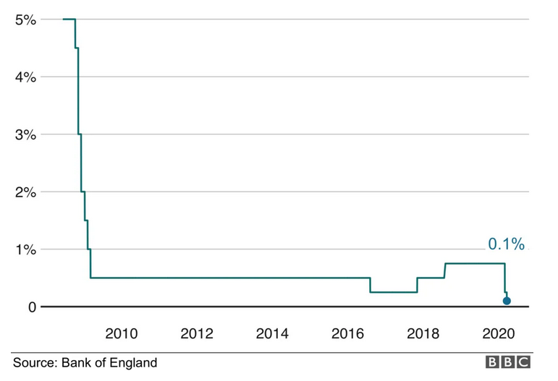
Fig 1

Factors Influencing Debt Sustainability
Debt management relies on balancing primary balances, growth-corrected interest rates, and adjustments that affect the debt-to-GDP ratio, See Section 4.13. Specifically, the rate at which debt grows depends on a country’s primary balance (the difference between government revenue and expenditure excluding debt interest), the nominal interest rate on government debt, and GDP growth rates. Variations in interest costs and growth rates have profound implications for debt sustainability, as low or negative growth-corrected interest rates allow countries to manage higher debt loads without adverse fiscal consequences, See Section 4.13.

Valuation of Debt Stock
The evolution of debt stock valuation, whether calculated at market value or face value, is critical in assessing fiscal health. Market value often diverges from face value, especially in periods of low yields, where the premium for government debt increases. This divergence reflects the unique challenges governments face in valuing debt amid fluctuating interest rates and currency movements, See Section 4.14. Both measures provide insights into a government’s ability to manage debt obligations, with face value focusing on nominal debt obligations and market value accounting for bond prices and yields, See Section 4.14.

The Role of Interest Rates and GDP Growth Rates
The relationship between interest rates and GDP growth rates is pivotal to debt sustainability. When the interest rate on debt exceeds the GDP growth rate, governments must eventually balance deficits with increased revenue or reduced spending to prevent rising debt-to-GDP ratios, See Section 4.15. However, when interest rates are lower than GDP growth, debt can potentially be rolled over without increasing fiscal strain, as seen in the UK and US, where recent decades have seen negative growth-corrected interest rates. This condition has allowed these governments to maintain high debt levels with relatively low servicing costs, although the broader economic impacts of elevated debt remain an ongoing concern.

Conclusion: Post-Pandemic Fiscal Risks
Overall, the COVID-19 pandemic has left a lasting impact on global government debt risks. Higher debt levels across countries have heightened fiscal vulnerability, necessitating careful debt management to maintain economic stability.

REFERENCES

BBC, Bank of England [Fig 1] Available at: https://www.bbc.com/news/business-51962982
Ellison, M., and Scott, A., Managing the UK National Debt 1694-2018, American Economic Journal: Macroeconomics, 2020.
Impact of haircuts in sovereign restructurings on subsequent bond spreads in Cruces, J., and Trebesch, C.
Sovereign Defaults: The Price of Haircuts, American Economic Journal: Macroeconomics.
De Rugy, V., and Salmon, J., Debt and Growth: A Decade of Studies
Mercatus Center Policy Brief, April 2020
Blanchard, O., Public debt and low interest rates, American Economic Review, 2019.

INTERNATIONAL TRADE
Overview
In 2020, global merchandise trade decreased by approximately 8.9%, marking the steepest drop since the 2008 financial crisis, marking the steepest drop since the 2008 financial crisis. 1
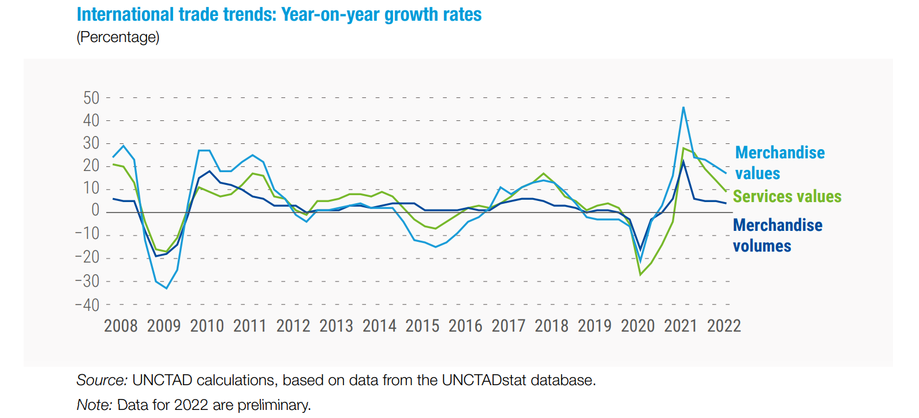

The World Trade Organization (WTO) had predicted an even sharper contraction of between 13% and 32% at the height of the pandemic. 2

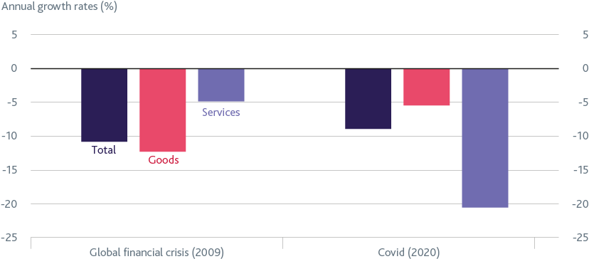

Sector-Specific Impacts
The services sector was hit particularly hard, with trade in services falling by over 20% in 2020, compared to a lesser decline in goods trade. 3
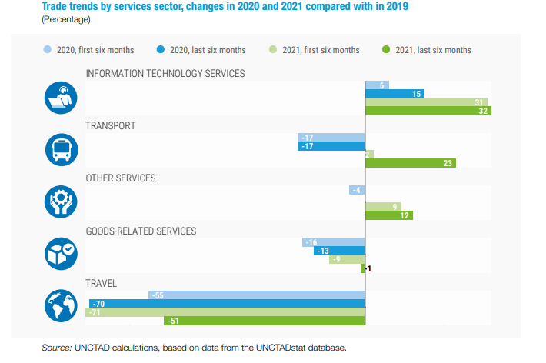

Travel and tourism, which rely heavily on cross-border movement, experienced a 72% drop in trade value during the pandemic. 4
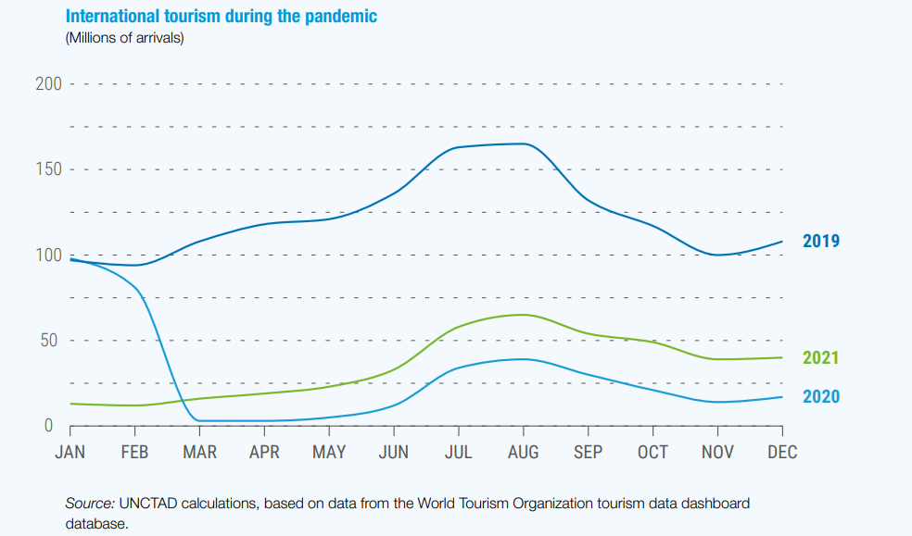
Reasons to why it was heavily affected:
Logistical Challenges
Lockdowns and restrictions led to port closures and transport disruptions, significantly increasing shipping costs and delaying deliveries. This situation strained supply chains, particularly for industries reliant on just-in-time inventory systems. 5 6

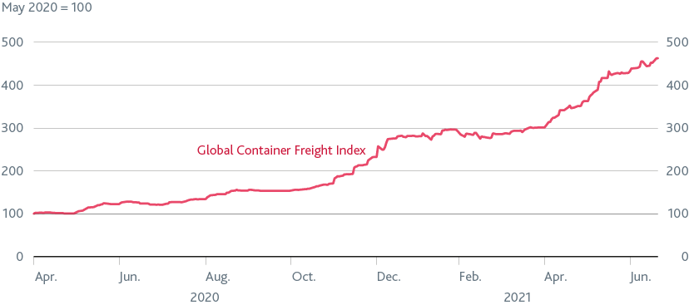

Manufacturing Slowdowns
Factory closures, especially in manufacturing hubs like China, resulted in delays in production and shortages of critical components for various industries globally. This was particularly evident in sectors such as automotive and electronics. 7

E-commerce Surge
The pandemic accelerated the shift towards e-commerce as consumers turned to online shopping due to lockdowns and health concerns. Global retail e-commerce sales grew by about 19% in 2020 alone. This change is expected to have lasting effects on consumer behavior and business models. 8
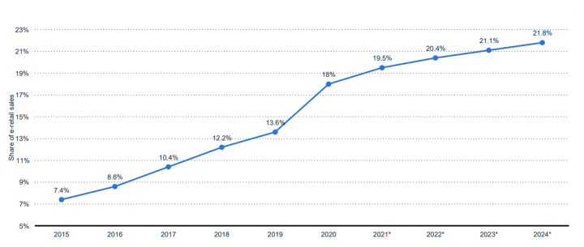

Changing Consumer Needs
While demand for certain goods like medical supplies and home office equipment surged, overall consumer spending declined due to economic uncertainty and job losses. This dual impact led to fluctuating import and export demands across different countries. 9

Severe Reduction in Physical Interaction Services
Services that require physical presence, such as travel, hospitality, and personal services, experienced dramatic declines. For instance, global services trade fell by over 20% in 2020, nearly four times the decline seen in goods trade. The travel sector was particularly hard hit, with a reduction of more than 50% in trade value during the pandemic. 10 11 12

Impact of Travel Restrictions
Lockdowns and border closures severely restricted cross-border movement of people, which is essential for modes of services trade that depend on physical presence. This led to a significant decrease in exports related to tourism and business travel as consumers hesitated to travel to areas with high infection rates. 13

How Government Helped To Recover
Financial Support and Stimulus Packages
Many countries provided direct financial aid to businesses affected by the pandemic, including grants and subsidies. For example, stimulus packages across multiple economies totaled about $100 billion in direct aid to the tourism industry and related sectors, which also benefited trade indirectly. 14

Investment in Infrastructure
There was significant investment in transportation and logistics infrastructure to improve efficiency and reduce bottlenecks in supply chains. This was vital for ensuring that goods could move more freely across borders. 15 16

Trade Policy Adjustments
Governments adjusted trade policies to facilitate recovery. This included reducing tariffs on essential goods and implementing measures to keep supply chains open, which were crucial for ramping up the supply of critical products like medical supplies and vaccines. 17 18

Encouragement of Digital Trade
The pandemic accelerated the shift towards digital commerce, prompting governments to support initiatives that encouraged e-commerce and digital transactions, helping businesses adapt to changing consumer behaviors. 15 16

Domestic Market Stimulus
To counteract the decline in international demand, many governments implemented programs to stimulate domestic consumption, thereby supporting local businesses that rely on international supply chains. 15 16

https://unctad.org/news/global-trades-recovery-covid-19-crisis-hits-record-high

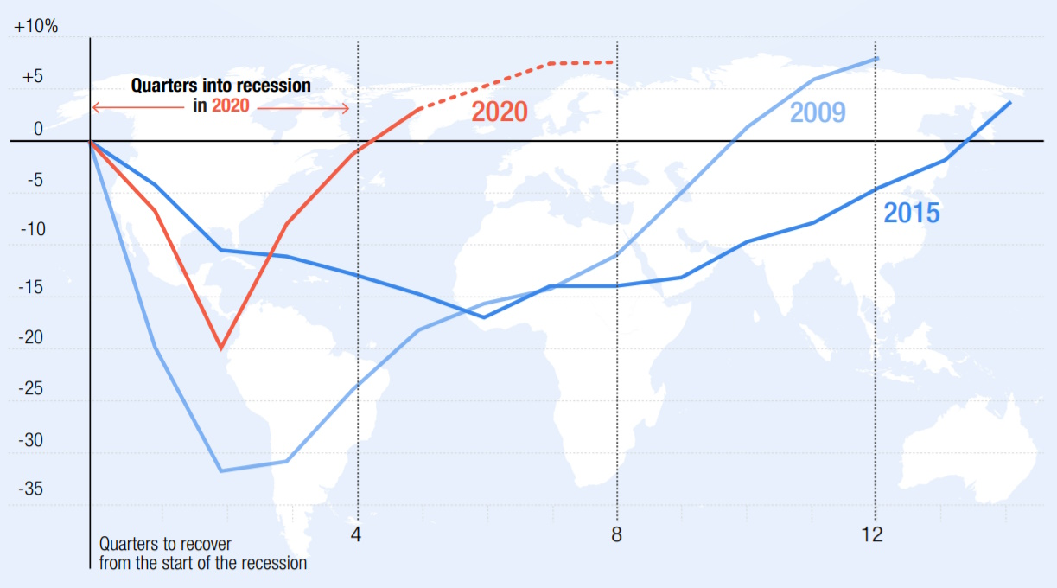

REFERENCES
IMF World Economic Outlook April 2021 and Bank calculations. Data show global trade volumes. Freightos Baltic Index and Bank calculations.
https://www.weforum.org/stories/2021/08/covid19-pandemic-trade-services-goods/
World Trade Organization, Trade statistics and outlook: Trade set to plunge as COVID-19 pandemic upends. global economy (8 April 2020), p 1
https://committees.parliament.uk/publications/2177/documents/20125/default/

UNCTAD calculations, based on data from the UNCTADstat database.
Note: Data for 2022 are preliminary. UNCTAD calculations, based on statistics from China, the United States and the European Union
https://unctad.org/system/files/official-document/osg2022d1_en.pdf

eCommerce Share of Total Global Retail Sales 2015-2024
https://www.trade.gov/impact-covid-pandemic-ecommerce

UNWTO (January 2023). Actual data for 2022 is preliminary and based on estimates for destinations which have not yet reported results.
https://www.unwto.org/impact-assessment-of-the-covid-19-outbreak-on-international-tourism
RECESSION
The COVID-19 pandemic has caused a historic economic shock, prompting widespread recessions, disrupting global value chains, and leaving lasting scars on economies worldwide. The Global Economic Prospects report provides a detailed analysis of the pandemic’s implications across various dimensions, including the depth of the recession, growth scenarios, challenges for low-income countries (LICs), and regional macroeconomic effects.

Key Indicators:
Deep declines in trade, manufacturing, and service industries demonstrate the extensive damage inflicted on both advanced and developing economies.

1. Inflation Dynamics
The COVID-19 pandemic created divergent inflationary pressures globally:
- Deflationary Pressures:
Demand Collapse: With lockdowns restricting movement and economic activity, consumer demand plummeted for non-essential goods and services.
Oil Price Declines: A sharp fall in oil prices, driven by reduced transportation and industrial activity, contributed to lower production and transportation costs, pushing inflation down.
Monetary Stimulus: Central banks implemented expansionary monetary policies, which prevented deflation but did not generate immediate inflation due to suppressed demand.
- Inflationary Pressures:
Supply Chain Disruptions: Interruptions in global value chains led to shortages of certain goods (e.g., medical supplies, electronics), causing localized price spikes.
Food Prices: Disruptions in agricultural production and logistics led to an increase in food prices, disproportionately affecting low-income households.
Emerging Markets: Many emerging economies experienced higher inflation due to currency depreciation and import dependency.
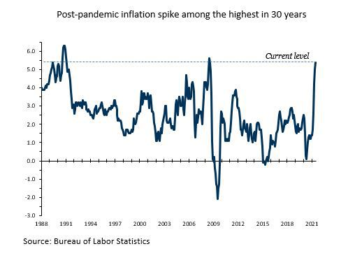
Overall, advanced economies experienced lower-than-usual inflation, while some developing economies faced inflationary pressures due to structural vulnerabilities.

2. Drop in Stock Markets
The global equity markets witnessed sharp declines at the onset of the pandemic, followed by a volatile recovery:
- Initial Declines:
In early 2020, global stock indices fell sharply as uncertainty about the virus’s spread and economic impact spooked investors.
Major indices like the S&P 500 dropped over 30% within weeks, reflecting panic selling and reduced investor confidence.
- Recovery and Volatility:
Aggressive monetary and fiscal interventions stabilized markets by mid-2020, leading to a recovery in equity prices.
However, sectors such as travel, tourism, and hospitality remained depressed, while tech and healthcare stocks surged due to shifting consumer behavior and demand for digital solutions.
- Implications:
The initial market crash wiped out trillions of dollars in global wealth, affecting pensions, savings, and corporate valuations.
Recovery was uneven, exacerbating wealth inequality as financial markets benefited wealthier individuals with asset holdings, while others faced job and income losses.
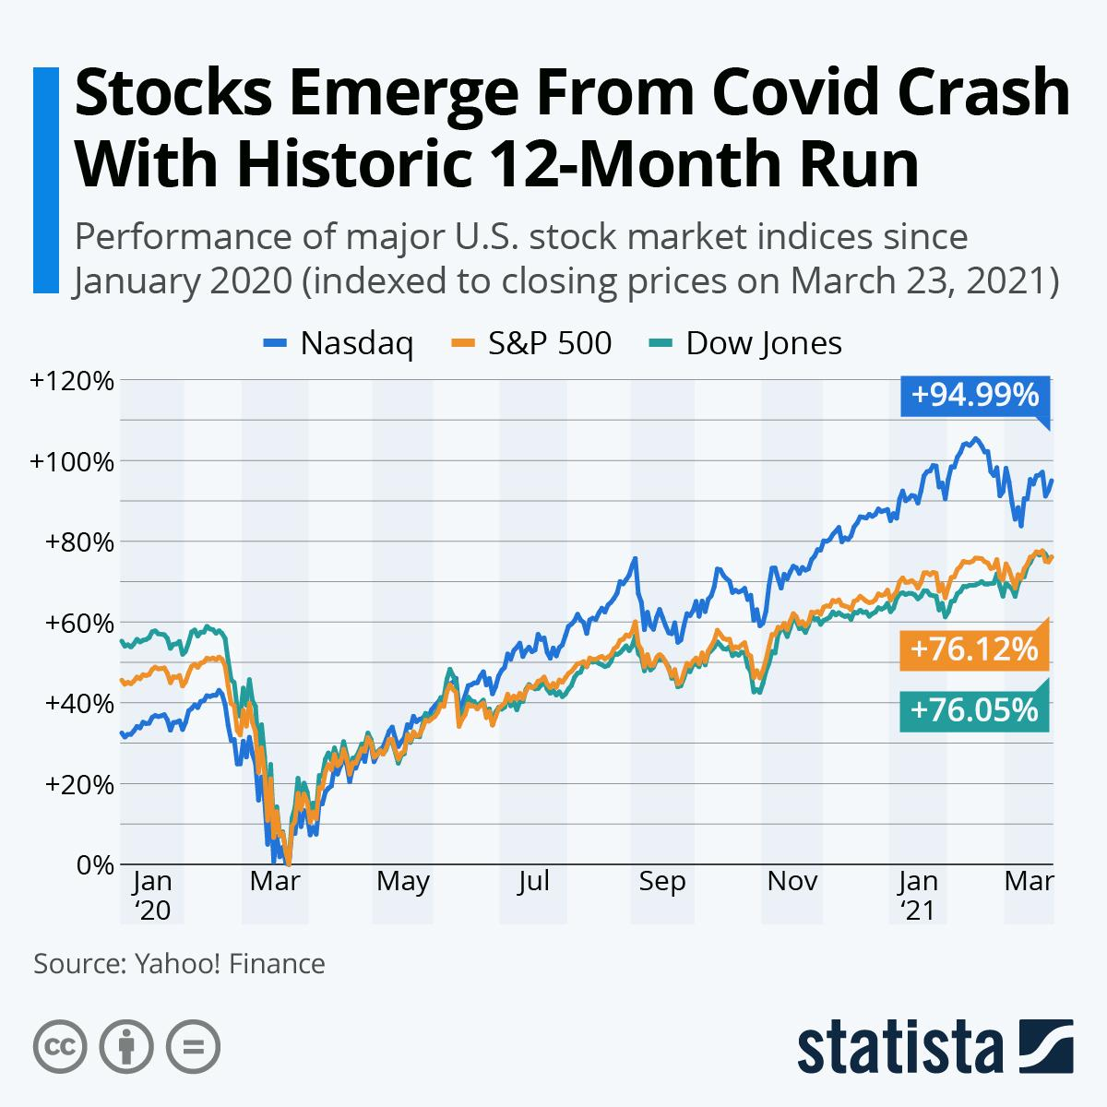

3. Consumer and Business Confidence
- Consumer Confidence:
Confidence indices dropped to record lows globally as households faced uncertainty about employment, income stability, and health risks.
- Business Confidence:
Investment decisions were postponed or canceled as businesses braced for prolonged uncertainty, leading to reduced industrial production and job creation.
Factors of Recession:

1. Depth of the COVID-19 Recession
The COVID-19 recession stands out as one of the most severe global economic contractions since 1870.
- Historical Comparisons: An analysis of 183 economies over 150 years reveals that this downturn is unparalleled during peacetime, affecting a vast majority of countries and economic sectors simultaneously. Past recessions typically resulted from financial crises, oil price shocks, or regional conflicts; the current crisis, triggered by a global pandemic, combines demand, supply, and health shocks.
- Scope and Magnitude: The pandemic has caused steep GDP contractions, widespread unemployment, and plummeting investment rates, while consumer confidence has hit historic lows. Unlike isolated recessions, the simultaneous nature of this downturn exacerbates its global impact.

2. Regional Macroeconomic Implications
The economic impact of COVID-19 varies across regions, influenced by unique structural and fiscal vulnerabilities:

East Asia and Pacific
- Strengths:
Early containment measures and a strong manufacturing base have supported recovery.
China’s robust rebound has provided a partial cushion for regional economies.
- Vulnerabilities:
Heavy reliance on global trade exposes the region to prolonged disruptions in value chains.

Europe and Central Asia
- Challenges:
High dependency on EU markets for trade and tourism.
Limited fiscal capacity to sustain prolonged recovery efforts.
- Outlook:
Recovery will depend heavily on coordinated regional responses and EU economic stabilization.

3. Outlook for Low-Income Countries
Low-income countries face unique and severe challenges due to their economic and structural vulnerabilities:
- Healthcare Deficits:
Limited testing, treatment, and vaccination capacity exacerbate mortality rates and economic disruptions.
Health crises lead to a reduction in productivity and long-term human capital losses.
- Economic Dependencies:
Heavy reliance on tourism, remittances, and commodities, all of which have faced substantial downturns during the pandemic.
Informal economies, constituting a large portion of employment, lack resilience and access to formal support mechanisms.
- Fiscal Constraints:
LICs struggle to implement stimulus measures due to limited access to capital markets and lower tax revenues.
Rising debt levels hinder long-term fiscal sustainability, increasing dependence on external aid.
- Poverty and Inequality:
The pandemic has reversed decades of poverty reduction, pushing millions into extreme poverty.

4. Scenarios of Possible Growth Outcomes
Given the unprecedented uncertainty, the report outlines three potential growth scenarios for the near term:
- Best-case scenario:
Rapid virus containment and vaccine distribution.
Swift economic recovery driven by strong fiscal and monetary responses.
Economic output will return to pre-pandemic levels by late 2022.
- Middle Scenario:
Intermittent outbreaks and slow vaccine distribution.
Gradual recovery with lingering vulnerabilities, especially in emerging markets.
Output remains below pre-pandemic trends, prolonging recovery timelines.
- Worst-case scenario:
Persistent outbreaks, vaccine delays, and limited fiscal space in developing economies.

Conclusion
The COVID-19 pandemic has disrupted economies at an unprecedented scale, with severe short-term and long-term consequences:
- LICs face compounding challenges due to limited healthcare and fiscal capabilities.
- Regional vulnerabilities, such as reliance on tourism, trade, and oil, shape the recovery outlook.
- Prolonged recessions risk leaving deep scars, including reduced investment, weakened human capital, and retreat from globalization.

Policy Recommendations
- Global Cooperation: Enhanced international coordination for vaccine distribution and financial aid.
- Targeted Fiscal Support: Prioritize healthcare investments and social safety nets to mitigate human capital losses.
- Structural Reforms: Foster diversification in vulnerable economies to reduce dependency on volatile sectors like tourism and oil.

REFERENCES
World Bank. (2020). Global Economic Prospects, June 2020: The Impact of COVID-19 on Global Economies. Washington, DC: World Bank. Retrieved from https://www.worldbank.org/en/publication/global-economic-prospects.
European Central Bank. (2021). Scarring effects of the pandemic on the global economy – reviewing recent evidence. European Central Bank Economic Bulletin, Issue 7, 2021. Retrieved from https://www.ecb.europa.eu/press/economic-bulletin/focus/2021/html/ecb.ebbox202107_01~f8314090a4.en.html.

CONSUMER BEHAVIOUR AND SPENDING PATTERN
The COVID-19 pandemic reshaped global economies and profoundly influenced consumer behavior. Financial uncertainty, health concerns, and changing priorities led individuals to reassess their spending patterns, with a distinct shift from discretionary luxuries to essential necessities. This report explores these behavioral shifts, analyzing spending trends and their underlying factors.

Framework for Analysis
To understand consumer behavior during the pandemic, we classify spending into two categories:
- Necessities: Goods and services critical for day-to-day living.
- Luxuries: Discretionary items considered non-essential for survival but valued for comfort or status.

Behavioral Shifts: Necessities vs. Luxuries

Necessities: High-Priority Items
- Health and Hygiene Products
Products like masks, hand sanitizers, disinfectants, and medical supplies saw exponential demand growth.
Increased spending due to heightened awareness of personal and public health risks.
Example: In the U.S., hand sanitizer sales increased by 313% in March 2020 compared to the previous year.
- Groceries and Food Supplies
Shift from dining out to home cooking due to lockdowns.
Panic-buying and stockpiling of non-perishable goods like canned foods and grains.
Subscription-based meal kits grew in popularity, addressing convenience and safety concerns.
- Home Utilities and Internet Services
With work-from-home (WFH) and remote learning becoming the norm, households invested in better internet connections, routers, and digital devices.
Increased electricity, water, and heating/cooling usage due to extended time at home.
- Health Services and Telemedicine
Transition to online health consultations via telemedicine platforms.
Mental health services saw a rise in demand as anxiety and stress levels soared.

Luxuries: Low-Priority and Discretionary Items
- Travel and Leisure
Air travel, vacations, and hotel bookings dropped sharply as international borders closed.
Domestic travel and "staycations" partially offset the decline, as consumers sought safer, nearby alternatives.
Data: Global air passenger numbers fell by 60% in 2020 compared to 2019, per the International Air Transport Association (IATA).
- Fashion and Non-Essential Retail
Luxury clothing, formal wear, and high-end accessories saw decreased demand as social events were canceled.
Loungewear and athleisure emerged as a growing trend, blending comfort with utility.
- Dining Out and Entertainment
Restaurant revenues dropped significantly, while food delivery services like Uber Eats and DoorDash surged.
Home entertainment, including streaming services and gaming, became preferred leisure options.
Example: Netflix added 36.6 million new subscribers in 2020, a 31% increase from 2019.
- Home Improvement
Spending on furniture, home office setups, and fitness equipment increased as people adapted to WFH and fitness-at-home lifestyles.

Visual Analysis

1. Spending Trends by Category

Category | Pre-COVID Spending ($) | COVID Spending ($) | % Change
Health & Hygiene | 50M | 150M | +200%
Travel & Leisure | 200M | 80M | -60%
Dining Out | 100M | 40M | -60%
Home Entertainment | 70M | 120M | +71%
Groceries | 150M | 180M | +20%
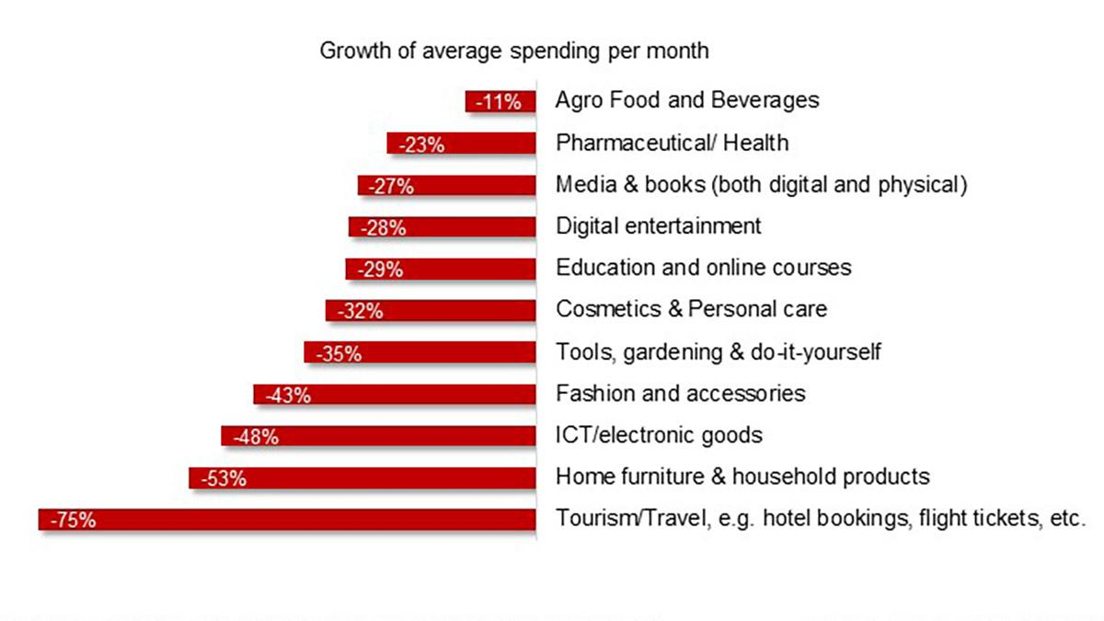

Future Implications
- Necessities:
Focus on health and wellness is likely to remain high.
Hybrid work models may sustain demand for digital services and home improvements.
- Luxuries:
Consumers may prioritize experiential luxury (e.g., travel, events) over material possessions.
Sustainability and quality will drive future luxury purchases.

Conclusion

The COVID-19 pandemic significantly altered consumer behavior, driving a clear shift from discretionary spending on luxuries to prioritizing necessities. Health concerns, financial uncertainty, and lifestyle changes shaped these patterns, highlighting the human tendency to adapt during crises.

REFERENCES
Nielsen, Grocery Spending Trends During COVID-19, 2020.
International Air Transport Association (IATA), Passenger Traffic Analysis, 2020.
Netflix Earnings Report, 2020.
Statista, Global Spending on Health and Hygiene Products, 2021.

EQUILIBRIUM INTEREST RATES
Introduction
Equilibrium interest rates represent the balance point where the supply of funds from savers matches the demand for funds by borrowers in financial markets. At this rate, the quantity of funds individuals and institutions are willing to lend equals the amount others are willing to borrow, ensuring stability in the financial system. The equilibrium interest rate is influenced by factors such as economic growth, inflation expectations, monetary policy, and global market conditions.

The COVID-19 pandemic significantly impacted equilibrium interest rates by disrupting economic activity and altering supply-demand dynamics in financial markets. Central banks worldwide lowered policy rates to near-zero levels to stimulate borrowing and investment amid the crisis. This created a downward pressure on equilibrium interest rates as savers faced reduced returns, and borrowers benefited from cheaper access to credit. Simultaneously, heightened uncertainty and reduced consumer confidence shifted the demand for safe assets, further influencing interest rates. The pandemic underscored the interconnectedness of global economies and how unexpected shocks can reshape financial equilibria.

Pre-Pandemic performance

Before the pandemic, equilibrium interest rates in most advanced economies were at historically low levels. This trend reflected the aftermath of the 2008 financial crisis and the gradual global economic recovery that followed. Interest rates were influenced by structural and cyclical factors, which included:

1. Structural Factors Influencing Pre-Pandemic Rates :
Demographic Shifts : Aging populations in advanced economies reduced labor supply growth and increased savings, lowering natural interest rates.

Productivity Stagnation: Slower productivity growth in key sectors reduced the demand for capital, keeping interest rates subdued.

2. Cyclical Factors Influencing Pre-Pandemic Rates :
Central Bank Policies: Many central banks maintained accommodative monetary policies to sustain economic recovery. For example, the Federal Reserve kept rates relatively low post-2008 to encourage investment and spending.

Inflation Expectations: Consistently low inflation reduced the pressure on central banks to raise rates, creating a stable low-interest-rate environment.

Interest Rate Trends vs Inflation Rates (2015–2019):
This graph plots policy interest rates alongside inflation rates to show their correlation.

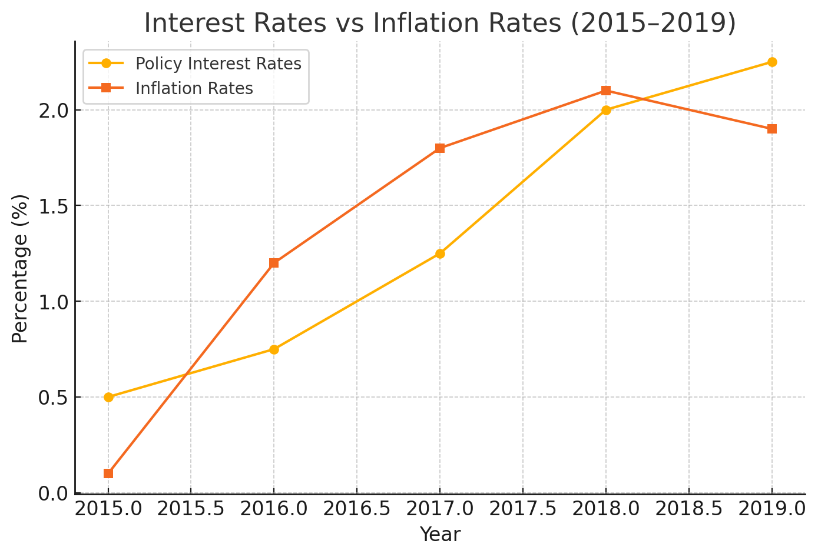
This graph shows the relationship between policy interest rates and inflation rates in the pre-pandemic period:
Observation : Policy interest rates closely followed inflation trends, rising when inflation increased and stabilizing as inflation steadied near central bank targets.
Implication : Central banks' actions were largely driven by inflation management, maintaining a balance to ensure economic growth without overheating.
Demographic Trends and Savings Rates (2010–2019):
This graph shows aging populations' effect on savings rates and its impact on equilibrium interest rates.
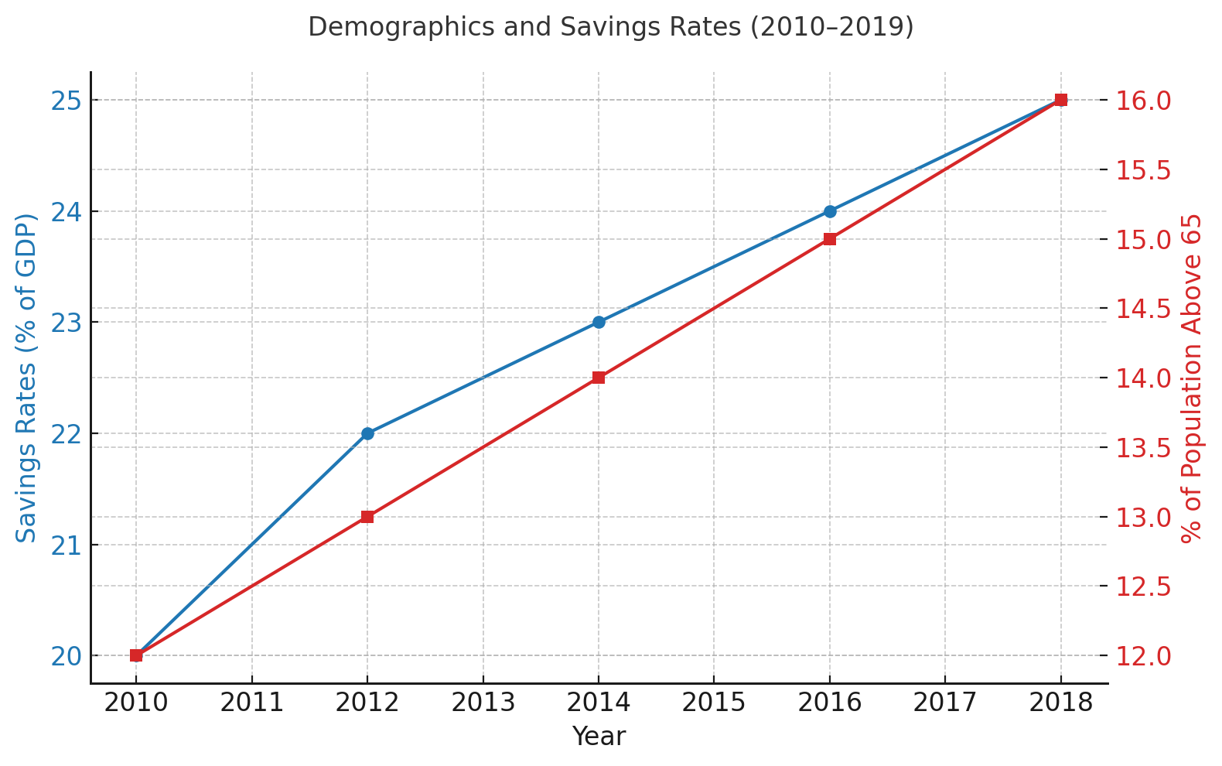
This dual-axis graph highlights the impact of aging populations on savings:
Observation : Savings rates increased steadily as the proportion of the population over 65 grew.
Implication : Aging demographics drove higher savings and reduced consumption, contributing to lower equilibrium interest rates due to excess liquidity in the financial system.
Global Productivity Growth (2010–2019):
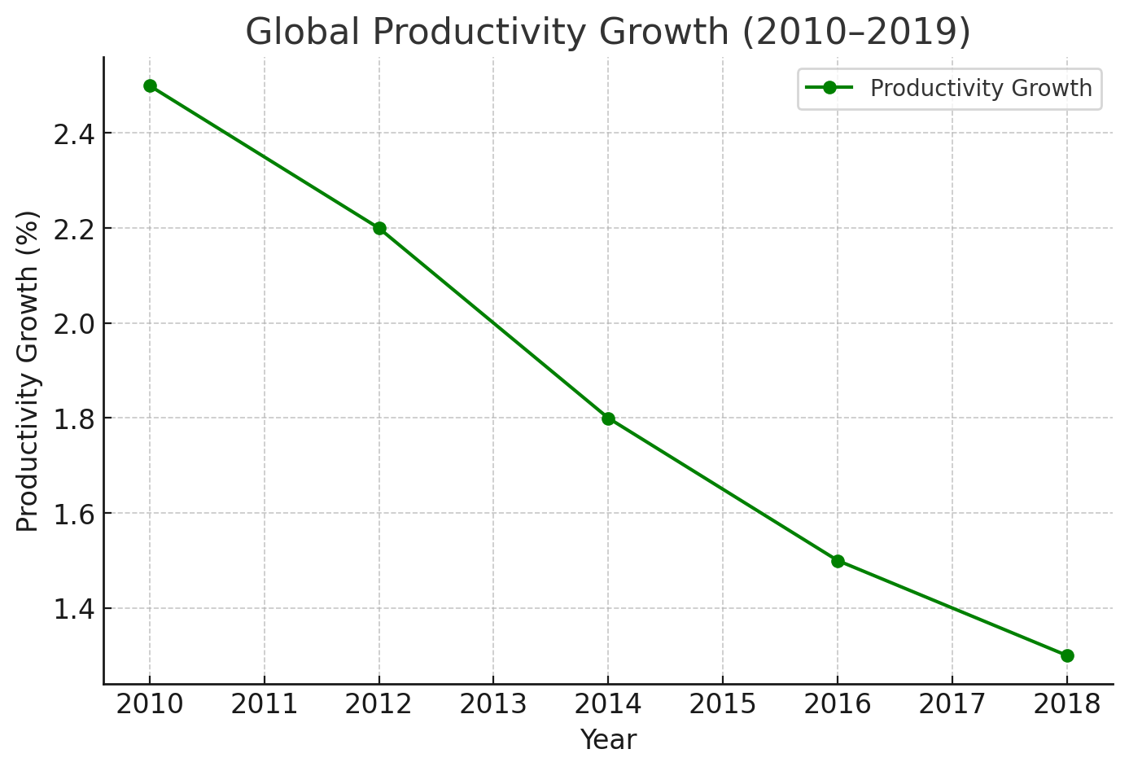
This line graph shows declining productivity growth globally:
Observation : Productivity growth declined consistently, from 2.5% in 2010 to 1.3% in 2019.
Implication : Reduced efficiency in output generation decreased the demand for capital investments, further suppressing interest rates in the lead-up to the pandemic.
Post-Pandemic performance
Following the COVID-19 pandemic, the global economy underwent significant changes, with central banks and governments implementing unprecedented monetary and fiscal measures to combat the economic downturn. These measures led to substantial shifts in equilibrium interest rates, which had previously been at historically low levels.

Factors Influencing Post-Pandemic Rates :

Monetary Policies : Central banks slashed interest rates to near-zero levels and introduced unconventional measures like quantitative easing (QE). The Federal Reserve, European Central Bank (ECB), and other central banks injected liquidity into the financial system, which resulted in lower long-term interest rates. These actions were aimed at stimulating investment, consumption, and ensuring financial stability.

Fiscal Stimulus: Governments worldwide launched massive fiscal stimulus programs, including direct financial support to individuals and businesses, and increased public spending on healthcare and infrastructure. This led to a rise in public debt, but also increased demand for government bonds, further influencing interest rates.
Inflation Pressures : As economies began to recover, inflationary pressures began to build due to supply chain disruptions, labor shortages, and rising commodity prices. Initially, inflation was subdued during the early stages of the pandemic but picked up as demand recovered faster than supply, leading to a reconsideration of the accommodative policies by central banks.

Global Economic Recovery : Recovery rates varied significantly across regions. Advanced economies with better access to vaccines and greater fiscal resources recovered faster, while emerging markets faced longer recovery timelines, affecting the timing and speed of interest rate changes.

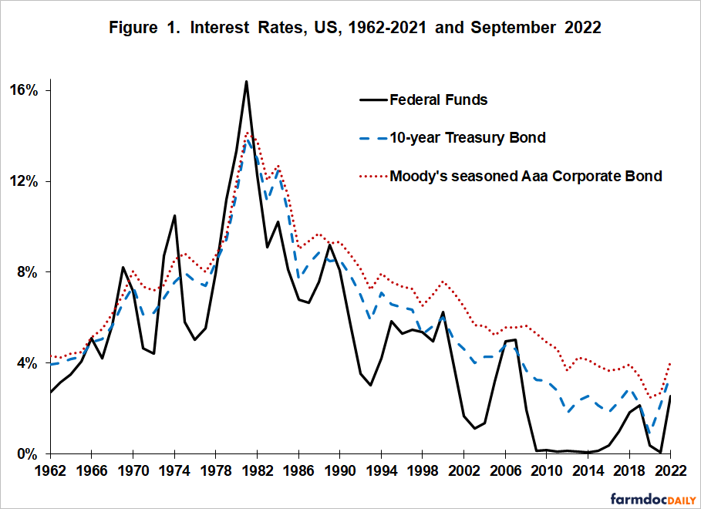
Policy Interest Rates vs Inflation Rates (2020–2022) :

Analysis : Initially, inflation was low in 2020, with central banks maintaining low interest rates to stimulate economic activity. As inflation rose in 2021–2022, many central banks started signaling or implementing interest rate hikes to curb inflation. This shift reflects the tension between supporting economic growth and controlling inflation.

Fiscal Stimulus vs Debt-to-GDP Ratios (2020–2022):
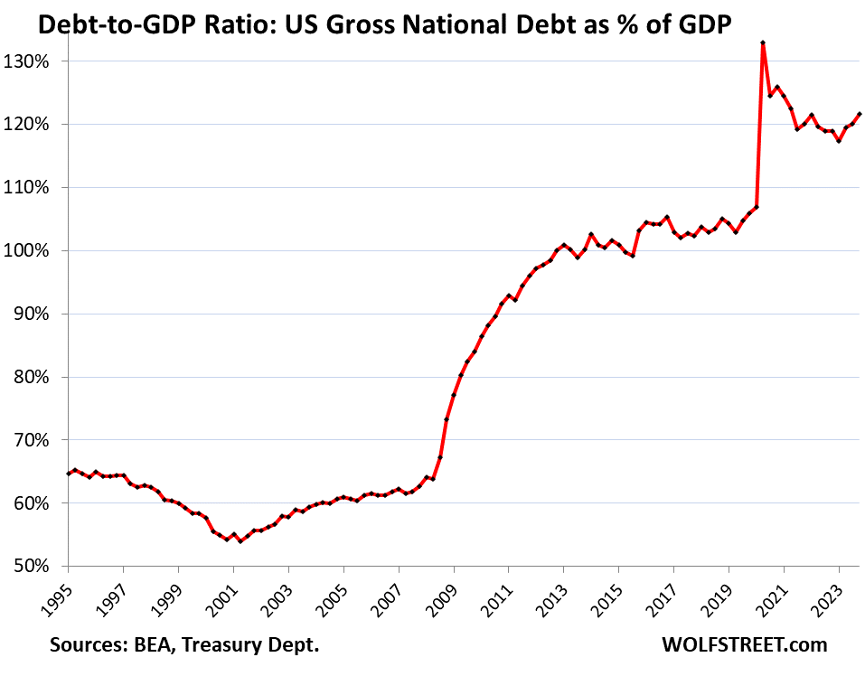
Analysis :The spike in Q2 2020 to 133% had occurred largely because GDP had collapsed, and to a lesser extent because the debt had begun to jump. Then, as the economy leaped out of the hole and then grew faster than the debt through Q1 2023, the Debt-to-GDP ratio declined.
But in Q2, Q3, and Q4 2023, it went in the wrong direction, as the government opened the spending floodgates and piled on debt at a scary rate, despite decent economic growth.
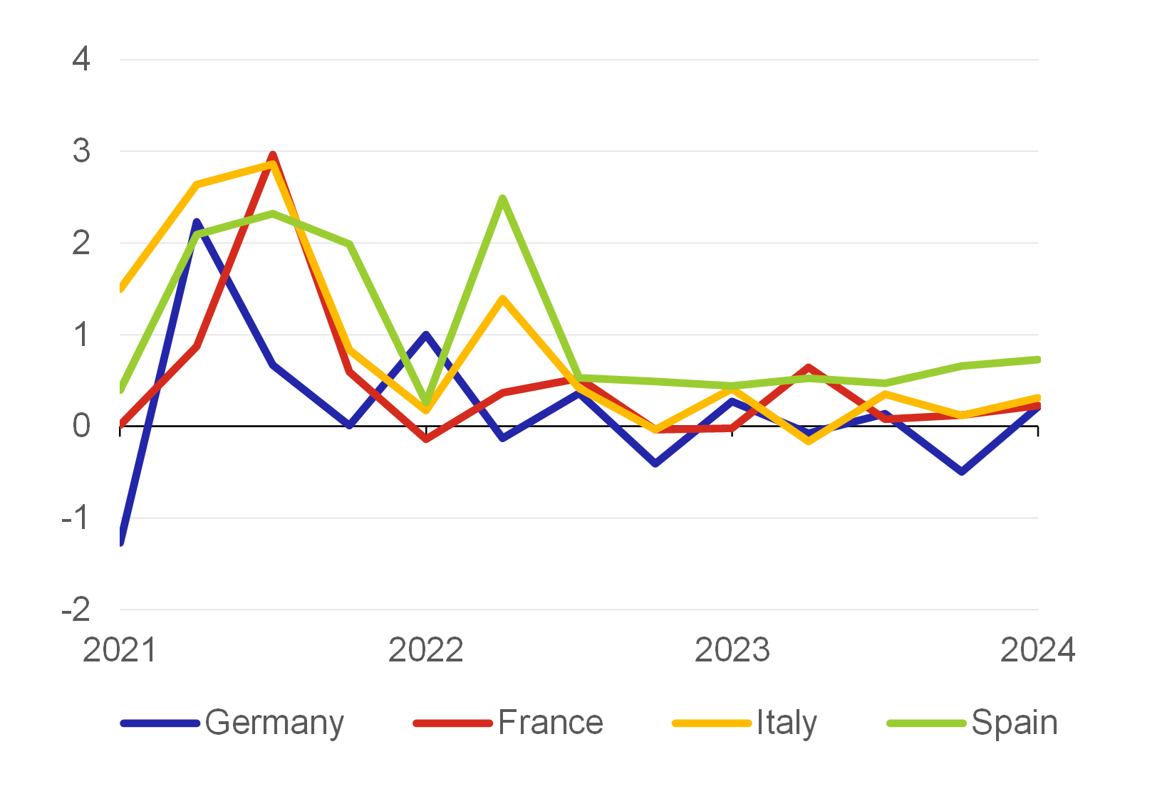
Economic Recovery Rates Across Regions (2020–2022):
Analysis : The second-largest economy in the euro area, France, grew at an average rate of 0.2% over the same period. Although this is hardly a dazzling performance by its standards, it is at least positive growth. Italy also maintained the same growth rate in the period under review. This was, however, a much better result, as this growth rate roughly corresponds to its potential. Fourth-placed Spain has recently been the clear leader of the Big Four.

REFERENCES

IMF. World Economic Outlook Database (2019)
World Bank. Global Economic Prospects (2019)
UN. World Population Prospects (2019 Revision)
OECD. Economic Outlook (2019)
Bureau of Labor Statistics. Global Productivity Reports (2019)
World Bank. Productivity and Growth Report (2019)
Global Economic Outlet
Federal Reserve Economic Data (FRED)
Bank for International Settlements (BIS)

FOREIGN DIRECT INVESTMENT
Introduction
Foreign Direct Investment (FDI) plays a pivotal role in global economic development by promoting the transfer of capital, technology, and expertise across borders. However, the COVID-19 pandemic has disrupted global economic activity, affecting FDI flows, investment decisions, and cross-border operations. The pandemic led to an unprecedented global economic slowdown, with significant contractions in international trade and investments. This report explores the impact of COVID-19 on FDI, analyzing its pre-pandemic performance, post-pandemic trends, and the factors influencing these changes.

Pre-Pandemic Performance of FDI

Before the pandemic, global FDI flows had been experiencing a steady increase after the recovery from the 2008 global financial crisis. The key factors driving FDI in this period included:

Key Factors Influencing Pre-Pandemic FDI:
- Globalization and Trade Liberalization: Strong economic integration across regions and trade agreements, such as the EU and NAFTA, encouraged cross-border investments.
- Technological Advancements: Innovations in technology, such as the digital economy, and the rise of emerging markets, particularly in Asia, led to more diversified FDI flows.
- Stable Global Economic Conditions: Before the pandemic, the global economy was largely stable, with consistent GDP growth, low inflation, and favorable market conditions.

Performance Analysis: Global FDI flows reached a peak in the mid-2010s, with particular growth in emerging markets. According to the United Nations Conference on Trade and Development (UNCTAD), FDI flows to developing countries accounted for more than half of the global FDI stock by 2019. However, growth had started to slow down as a result of rising protectionism and geopolitical uncertainties.

Post-Pandemic Performance of FDI

The onset of COVID-19 led to a sharp decline in global FDI, as countries implemented lockdowns and border restrictions, and multinational companies delayed or canceled investment projects. The effects on FDI were multifaceted:

Key Factors Influencing Post-Pandemic FDI:

- Lockdowns and Travel Restrictions: The immediate impact of COVID-19 included restrictions on mobility and investments in many sectors, particularly hospitality, retail, and manufacturing.
- Economic Contraction: The global recession triggered by COVID-19 reduced demand for investment in many industries, especially those dependent on consumer spending.
- Increased Geopolitical Tensions: Rising protectionism, national security concerns, and trade wars (e.g., the US-China trade dispute) further reduced investor confidence.

Performance Analysis: According to UNCTAD, global FDI fell by 35% in 2020, the sharpest decline since the global financial crisis. While certain sectors (such as digital infrastructure, pharmaceuticals, and healthcare) saw growth, overall FDI was severely impacted, particularly in developing economies. The rebound in FDI has been uneven, with developed economies experiencing quicker recoveries compared to emerging markets.

Global FDI Flows (2015–2022) :
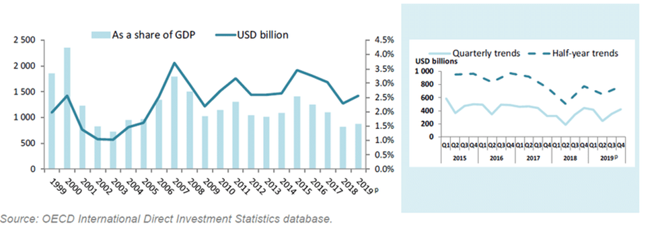
Analysis: FDI has been increasingly important for the development of developing countries. As seen in figure , the FDI in developing countries has gone from 14 billion US$ in 1985 to 690 billion US$ in 2017. At the same time the share of global FDI inflows has gone from 25% to 46%.

Sectoral FDI Trends Before and After the Pandemic

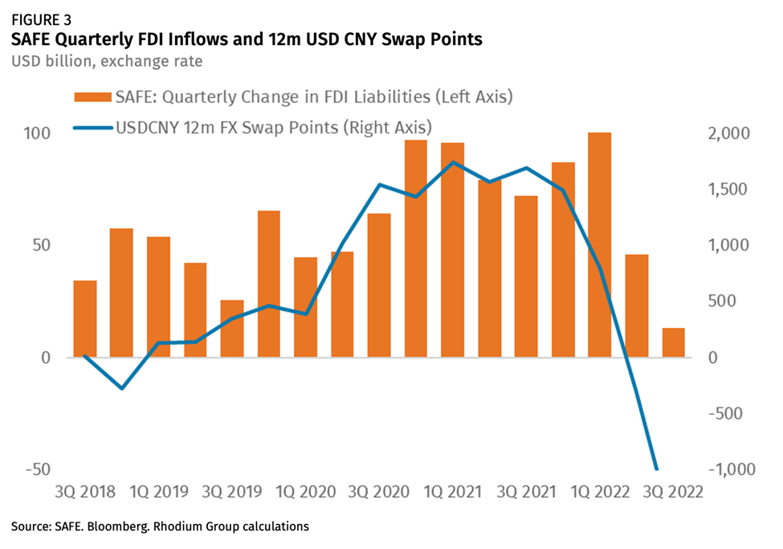
Analysis: It shows that FDI inflows strongly correlate with market expectations of rising exchange rates and high interest rate spreads. Inflows have skyrocketed since 2Q 2020 as investors decided to keep existing earnings in China and raise additional cash at low interest rates abroad and channel it into China to benefit from higher interest rates and exchange rate appreciation. Conversely, the rapid shift in global monetary conditions since 1Q 2022 has triggered a complete reversal of China’s FDI fortunes: Inflows went from a record high ($102 billion in 1Q) to a 20-year low ($13bn in 3Q) within just six months.

REFERENCES

United Nations Conference on Trade and Development (UNCTAD). World Investment Report 2021.
World Bank. Global Economic Prospects 2021

ANALYSIS AND DISCUSSION

The economic repercussions of the COVID-19 pandemic were swift, severe, and widespread, affecting multiple aspects of the global economy. This analysis delves into the specific impacts across various domains, highlighting the key areas of concern and the responses implemented to mitigate the crisis.

1. Impact on Global GDP
- The COVID-19 pandemic triggered one of the most significant global economic contractions since the Great Depression. In 2020, the global GDP shrank by approximately 3.0%, a stark reversal from the pre-pandemic growth trajectory. The economic downturn was driven by widespread lockdowns, reduced consumer spending, disruptions in trade, and a collapse in key industries such as tourism and hospitality.
- Advanced economies, including the United States, the European Union, and Japan, faced sharp GDP declines due to stringent containment measures and a drop in industrial output. Emerging markets, which typically rely heavily on exports and foreign investment, experienced slower recoveries due to limited healthcare capacity and greater economic vulnerabilities. The uneven economic impact highlighted disparities between wealthier nations with robust fiscal responses and lower-income countries with limited financial resources.

2. Rising Unemployment Rates
- The pandemic caused a dramatic surge in unemployment globally, as businesses were forced to downsize or close entirely due to reduced demand and restrictions on movement. According to the International Labour Organization (ILO), global working hours fell by 8.8% in 2020, equivalent to the loss of 255 million full-time jobs. The hardest-hit sectors included hospitality, tourism, retail, and entertainment, where physical presence is essential.
- Vulnerable groups, such as low-income workers, women, and young people, faced disproportionate job losses, exacerbating existing inequalities. Women, particularly those in caregiving roles or employed in the service industry, experienced higher unemployment rates as these sectors contracted. Youth unemployment also spiked as entry-level job opportunities vanished, leading to a "lost generation" effect, with long-term implications for labor market participation and income growth.

3. Supply Chain Disruptions
- COVID-19 exposed significant weaknesses in global supply chains, leading to widespread disruptions. The initial lockdowns in China, a major global manufacturing hub, caused a domino effect, delaying the supply of critical components worldwide. Industries such as automotive, electronics, and healthcare faced severe shortages, particularly in semiconductor chips, medical equipment, and essential consumer goods.
- Port congestion, shipping delays, and labor shortages further exacerbated these issues, driving up costs and extending delivery times. Companies relying on "just-in-time" inventory models struggled to adapt, highlighting the risks of over-reliance on a few suppliers or regions. In response, many businesses began reevaluating their supply chain strategies, focusing on diversification, increased stockpiling, and the adoption of digital tools for better visibility and real-time monitoring.

4. Government Fiscal and Monetary Interventions
- In an effort to stabilize their economies, governments around the world implemented extensive fiscal and monetary measures. These included direct financial aid to individuals and businesses, wage subsidies, tax deferrals, and enhanced unemployment benefits. The United States, for example, introduced stimulus packages totaling over $5 trillion, which included direct payments to citizens, extended unemployment benefits, and support for small businesses. The European Union launched the €750 billion Recovery Fund, aimed at helping member states weather the economic downturn and invest in sustainable growth.
- Central banks also played a crucial role in mitigating the economic impact. By cutting interest rates to near-zero levels, purchasing government bonds, and providing liquidity to financial markets, they aimed to encourage borrowing and investment. However, these interventions came at the cost of increased public debt, raising concerns about long-term fiscal sustainability and the potential for inflationary pressures as economies recover.

5. Shifts in Consumer Behavior
- The pandemic led to a fundamental shift in consumer spending patterns. With physical stores closed and mobility restricted, e-commerce experienced a significant boom. Consumers turned to online platforms for purchasing essential items, resulting in a surge in demand for digital services, home delivery, and contactless payment options.
- There was a noticeable pivot from discretionary spending (e.g., travel, luxury goods) to essential goods and services (e.g., groceries, healthcare products). The demand for home office equipment, fitness gear, and entertainment subscriptions like Netflix and Amazon Prime skyrocketed as people adapted to new work-from-home and lifestyle changes. This shift not only accelerated digital transformation but also highlighted the increasing importance of a robust online presence for businesses.

6. Long-term Economic Implications
- The COVID-19 pandemic's economic impact is likely to have long-term consequences, particularly in terms of increased public debt, shifts in labor markets, and changes in consumer behavior. Public debt levels have soared as governments borrowed heavily to finance relief measures, posing potential challenges for future fiscal policy and economic stability.
- The labor market is expected to undergo structural changes, with a greater emphasis on remote work, digital skills, and flexible employment arrangements. The rise of automation and artificial intelligence, accelerated by the pandemic, could lead to shifts in demand for certain skills, potentially displacing low-skilled workers while creating opportunities in tech-driven industries.
- Additionally, the crisis has underscored the need for greater economic resilience, prompting countries to invest in healthcare infrastructure, diversify supply chains, and strengthen social safety nets. The pandemic has highlighted the importance of preparedness for future global shocks, be it another health crisis or an environmental disaster.
In conclusion, the analysis of COVID-19's economic impact reveals deep and widespread disruptions across multiple sectors. The pandemic not only caused immediate economic damage but also exposed systemic vulnerabilities, prompting a reevaluation of economic strategies and policies. As the world moves towards recovery, it is essential to learn from this crisis and build a more resilient global economy capable of withstanding future shocks.

CONCLUSION

The COVID-19 pandemic has proven to be one of the most significant global disruptions of the modern era, reshaping economies, societies, and industries in unprecedented ways. The economic impact was immediate and severe, with global GDP experiencing a historic contraction, unemployment rates soaring to record levels, and critical supply chains facing severe disruptions. The crisis exposed deep vulnerabilities in both developed and developing economies, highlighting disparities in healthcare infrastructure, economic resilience, and access to social safety nets.

The swift and expansive fiscal and monetary interventions by governments helped to mitigate some of the immediate impacts, providing relief to individuals, businesses, and financial markets. However, these measures came at the cost of escalating public debt, which poses long-term challenges for fiscal sustainability. The pandemic also accelerated existing trends such as digital transformation, the shift towards remote work, and changes in consumer behavior, leading to a reevaluation of business strategies and economic policies worldwide.

As the global economy slowly recovers, it faces a landscape that has been fundamentally altered. Structural shifts in labor markets, increased automation, and changes in consumer preferences are likely to persist, requiring businesses and governments to adapt to a new economic reality. Building resilience against future crises has become a priority, with a focus on diversifying supply chains, strengthening healthcare systems, and enhancing social safety nets to better support vulnerable populations.

Ultimately, the COVID-19 pandemic has provided a critical lesson on the importance of preparedness, cooperation, and adaptability in the face of global challenges. The recovery process presents an opportunity to address existing inequalities, invest in sustainable development, and create a more inclusive and resilient global economy. By learning from this crisis and implementing proactive measures, we can build a stronger foundation for future growth and stability, ensuring that economies are better equipped to handle potential disruptions in the years to come.

